|  |
| --- |
| C:\Users\Tsubaki Yukino\Desktop\FlyAwayPlus Project\Capture.JPG |
| **FLY AWAY PLUS** |
| **Software Requirement Specification** |
|  |
| |  |  |  | | --- | --- | --- | | **Fly Away Plus** | | | | **Group Members** | Hoàng Nghĩa Đức | SE02882 | | Dương Thanh Hải | SE02856 | | Nguyễn Minh Hoàng | SE02819 | | Trần Mạnh Hiếu | SE02778 | | Phan Tiến Lực | SE02923 | | Lê Minh Thúy | SE02881 | | **Supervisor** | Mr. Nguyễn Văn Sang | | | **Project code** | FAP | | |
|  |

**- Hanoi, 05/2015 –**

**RECORD OF CHANGE**

*A-Added; M-Modified; D-Deleted

|  |  |  |  |  |
| --- | --- | --- | --- | --- |
| **Effective Date** | **Change Items** | **A*M, D** | **Change Description** | **New Version** |
| 2015/05/29 | Functional Requirement | A |  | v1.0 |
| Non-functional Requirement | A |  |
| 2015/06/11 | Use Case | M | Add new functions | v1.1 |
| Business Rules | M | Add new rules |
| Entity Relationship Diagram | M |  |
| Entity Detail | M |  |
|  |  |  |  |  |
|  |  |  |  |  |
|  |  |  |  |  |

**Table 1: Record of change**

**SIGNATURE PAGE**

|  |  |  |
| --- | --- | --- |
| **ORIGINATOR** | Trần Mạnh Hiếu |  |
|  | Developer |  |
|  |  |  |
|  |  |  |
| **REVIEWERS** | Lê Minh Thúy |  |
|  | Developer |  |
|  |  |  |
|  |  |  |
| **APPROVAL** | Nguyễn Văn Sang |  |
|  | Supervisor |  |
|  |  |  |

Table of Contents

**1.** **INTRODUCTION** 5

1.1. Purpose 5

1.2. Definitions and Acronyms 5

1.3. System Purpose 6

**2.** **OVERALL DESCRIPTION** 7

2.1. System overview 7

2.2. Use Case Diagram 7

2.3. Product Features 8

2.3.1. User Characteristics 11

2.3.2. User Documentation 12

2.3.3. Assumption 12

2.4. Entity Relation Model 12

2.4.1. Entity-Relationship Diagram 12

2.4.2. Entity Detail 12

**3.** **FUNCTIONAL SPECIFICATION** 15

3.1. Appendix 15

3.2. Business Rules 15

3.3. Use Cases 17

3.3.1. Common Module 17

3.3.2. Suggest Module 22

3.3.3. Social Module 25

3.3.4. Account Management Module 71

3.3.4.1. Login 72

3.3.4.2. UC049-Logout 73

3.3.4.3. UC050-Register 74

3.3.4.4. UC051-Edit profile 75

3.3.4.5. UC052-Forgot password 76

3.3.5. Admin Module 78

3.3.5.1. UC053-Lock user’s account 78

3.3.5.2. UC054-Unlock user’s account 79

3.3.5.3. UC055-Send warning 80

3.3.5.4. UC056-Review user 81

3.3.5.5. UC057-Review post 82

3.3.5.6. UC058-Delete user’s post 83

3.3.5.7. UC059-Reply question 84

**4.** **NON-FUNCTIONAL SPECIFICATION** 85

Reliability 85

Performance Requirements 85

User Interface 85

Maintainability 85

Usability 86

Security Requirements 86

Hardware/Software Requirements 86

# **INTRODUCTION**

## Purpose

This is the Software Requirements Specification for the FAP system. This document will provide the describing of general requirement and non-functional requirements of our FAP system. The FAP is designed to be a website that help users sharing their journey and connecting to their friends. These requirements will assure that the system will correctly and reliably perform its intended functionality. This specification will provide general, as well as specific requirements to be used in the design, testing and validation of the system. It is intended for both stakeholders and the project team of the system.

## Definitions and Acronyms

This section describes the definitions, terms, and acronyms that are used in software requirements specification.

|  |  |  |
| --- | --- | --- |
| **Acronym** | **Definition** | **Note** |
| FAP | Fly Away Project |  |

*Table 1-3: Definition and Acronyms*

## System Purpose

Our project – FAP will include some main functions of existing social networks and add some new features such as create room, connect user’s trips as a journey of their life. With the slogan “Share all we have!” we toward on sharing information and experiences between users and spread the joy of travelling together. People can make new friends by join in groups, Fly Away Plus and have new experiences together. We hope we can share all we have, and we hope people who loves travelling can be connected and easily share information about their trips.

# **OVERALL DESCRIPTION**

## System overview

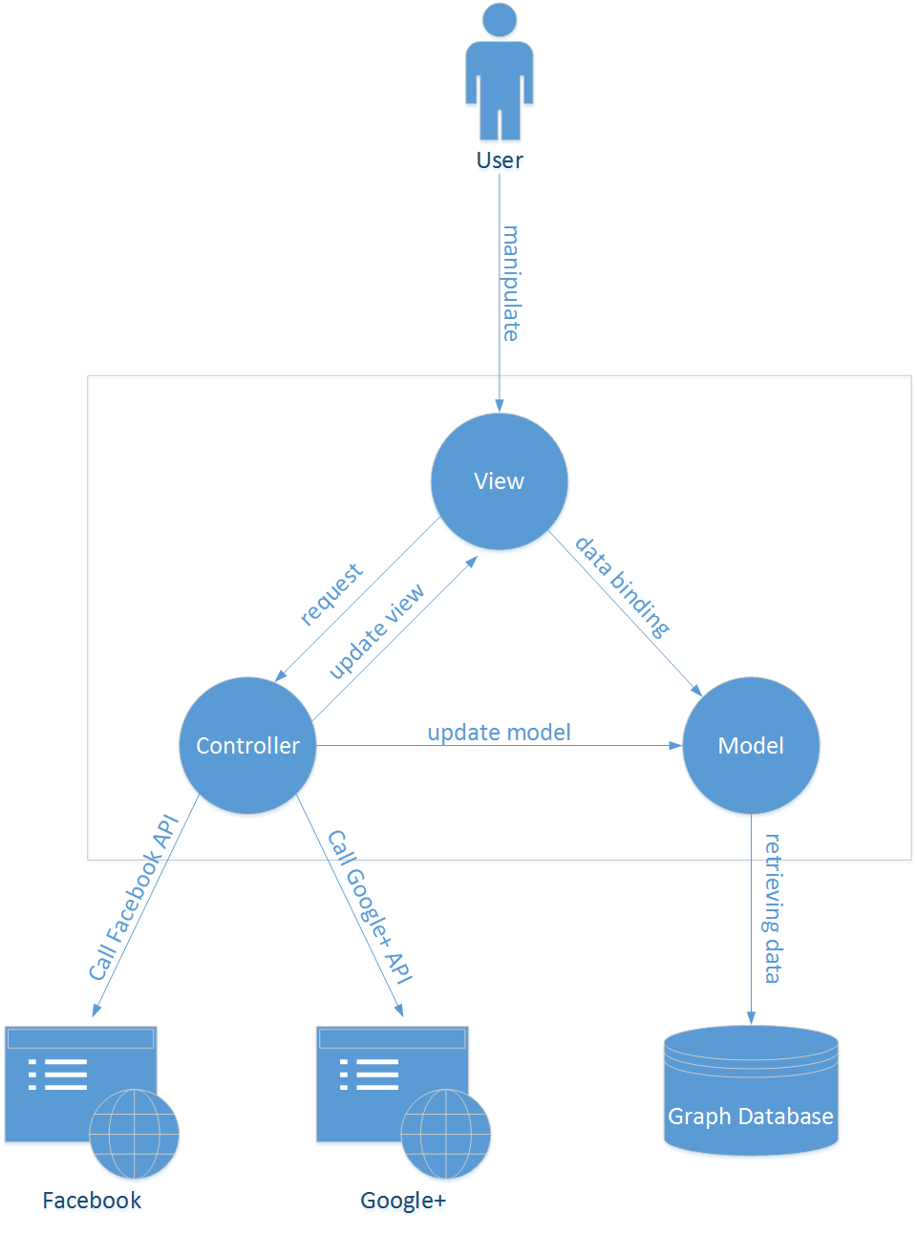

## Use Case Diagram

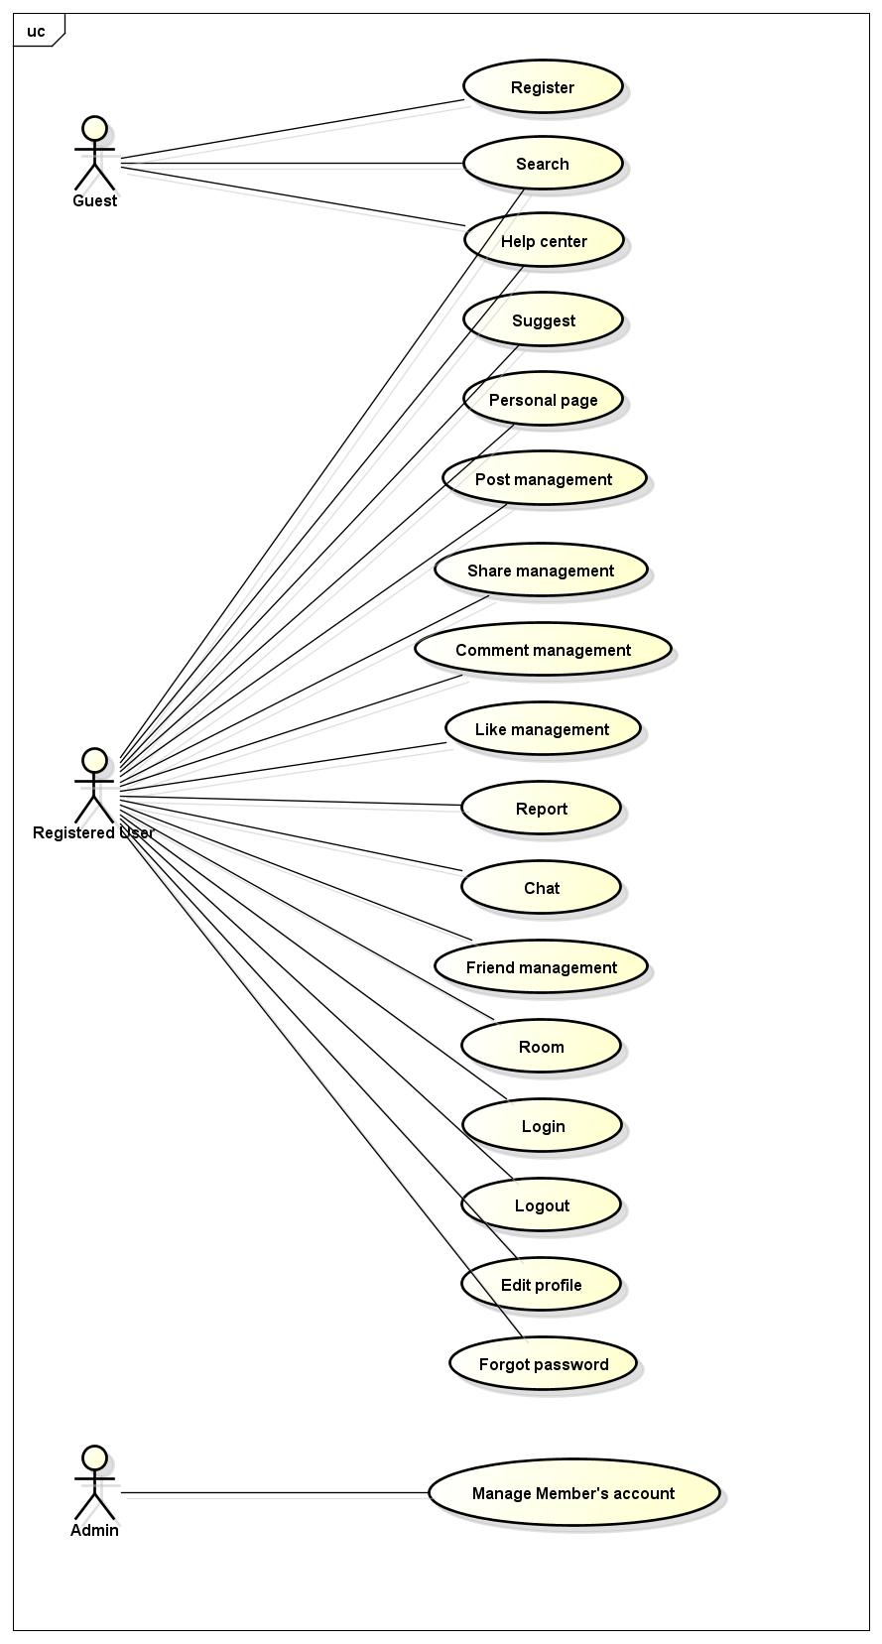

Figure 3-1: Use case diagram of FAP system

## Product Features

|  |  |  |  |
| --- | --- | --- | --- |
| **UC No.** | **Group of functions** | **Functions** | **Glossary** |
| **FAP GUEST/MEMBER MODULE** | | | |
| **Common Module** | | | |
|  | Search | Search user | Tìm kiếm tên người dùng |
|  | Search place | Tìm kiếm tên địa điểm |
|  | Search room | Tìm kiếm tên phòng |
|  | Help Center | Send question | Người dùng gửi các câu hỏi liên quan đến FAP |
|  | Basic guide | Hướng dẫn sử dụng cơ bản hệ thống FAP |
|  | Search question | Người dùng có thể tìm kiếm hướng dẫn sử dụng qua các câu hỏi thông thường |
| **FAP MEMBER MODULE** | | | |
| **Suggest Module** | | | |
|  | Suggest | Suggest place | Gợi ý những địa điểm nằm trong xu hướng mới nhất trên FAP |
|  | Suggest friend | Gợi ý kết bạn với những người dùng có nhiều bạn chung/thông tin chung |
|  | Look around | Gợi ý những bài viết được chú ý nhất quanh địa điểm hiện tại của người dùng |
| **Social Module** | | | |
|  | Personal Page | Display user’s personal page | Hiển thị các bài viết và ảnh của người dùng |
|  | Display post list | Hiển thị các bài viết của bạn bè và các gợi ý cho các địa điểm/hoạt động v.v… |
|  | View place | Hiển thị các bài viết liên quan đến một địa điểm |
|  | Display post details | Hiển thị chi tiết một bài post (bao gồm cả video, ảnh) |
|  | Display photo list | Hiển thị danh sách tất cả các ảnh của người dùng |
|  | Display video list | Hiển thị danh sách tất cả các video của người dùng |
|  | Display place list | Hiển thị danh sách tất cả các place của người dùng |
|  | Display notifications | Hiển thị thông báo mới |
|  | Post management | Add post | Thêm bài viết mới |
|  | Edit post | Chỉnh sửa bài viết đã tồn tại |
|  | Delete post | Xóa bài viết đã tồn tại và tất cả những nội dung liên quan |
|  | Share management | Share post | Chia sẻ một bài viết của một người dùng khác |
|  | Comment management | Add comment | Thêm một bình luận vào bài đăng hoặc ảnh |
|  | Edit comment | Chỉnh sửa một bình luận |
|  | Delete comment | Xóa một bình luận |
|  | Like management | Like/ Unlike | Thích/bỏ thích một bài đăng |
|  | Dislike/ Un-dislike | Không thích/bỏ không thích một bài đăng |
|  | Wishlist | Add to wishlist | Thêm 1 địa điểm vào danh sách mong muốn đến |
|  | Remove from wishlist | Xóa 1 địa điểm khỏi danh sách mong muốn đến |
|  | Report | Report a post | Báo cáo một bài đăng có nội dung vi phạm tới quản trị viên |
|  | Report an user | Báo cáo một người dùng có hành vi vi phạm tới quản trị viên |
|  | Chat | Chat with others | Tán gẫu với người dùng khác |
|  | Display message | Hiển thị message của người khác đến người dùng |
|  | Friend management | Add friend | Kết bạn với thành viên khác |
|  | Unfriend | Hủy kết bạn với một thành viên |
|  | Tag friend | Tag bạn bè vào bài đăng/ảnh |
|  | Room | Join room | Tham gia vào một phòng |
|  | Leave room | Thoát khỏi một phòng đã tham gia |
|  | Create room | Tạo một phòng |
|  | Edit room’s information | Chỉnh sửa thông tin một phòng đã tạo |
|  | Add event | Thêm một sự kiện vào lịch |
|  | Edit event | Sửa nội dung sự kiện |
|  | Delete event | Xóa một sự kiện |
|  | Add task | Thêm một công việc |
|  | Edit task | Sửa nội dung công việc |
|  | Delete task | Xóa một công việc |
|  | Approve request | Chỉnh sửa kế hoạch/lịch trình cho một chuyến đi trong phòng |
|  | Add member | Thêm thành viên mới vào phòng |
|  | Remove member | Mời một thành viên ra khỏi phòng |
|  | Chat | Tán gẫu với thành viên phòng |
| **Account Management Module** | | | |
|  | Login | Login by social network’s account | Đăng nhập bằng tài khoản Facebook/Google |
| Login by registered account | Đăng nhập bằng tài khoản được đăng ký trên FAP |
|  |  | Logout | Đăng xuất |
|  |  | Register | Đăng ký thành viên để sử dụng tất cả các chức năng của FAP |
|  |  | Edit Profile | Chỉnh sửa thông tin cá nhân |
|  |  | Forgot Password | Yêu cầu hệ thống giúp đỡ khi quên mật khẩu |
| **FAP ADMIN MODULE** | | | |
|  | Management Member’s account | Lock user’s account | Khóa tài khoản của người dùng vi phạm |
|  | Unlock user’s account | Mở khóa tài khoản người dùng |
|  | View all user | Hiển thị danh sách tất cả người dùng |
|  | Statistics | Thống kê các thông tin về trang web |
|  | Send warning | Gửi cảnh báo đến người dùng |
|  | Review user | Kiểm tra một người dùng bị báo cáo vi phạm |
|  | Review post | Kiểm tra một bài post bị báo cáo vi phạm |
|  | Hide post | Xóa một bài post có nội dung vi phạm |

### User Characteristics

This social networking website towards those who love travelling, looking for a website to share about their trips, searching for information to plan for their trips, review places they travelled, making friends and together creating a thoughtful plan for a trip. There are three main actors that system support:

* **Member:** Have account on system, they can use all functions of website. For example: Searching, posting, connect to friends etc…
* **Administrator:** They can use all functions of normal member and have an Administrator control panel to manage all configuration of system.

### User Documentation

|  |  |
| --- | --- |
| **Name** | **Description** |
| User Guide | Provide detailed explanation about the system, screens and guide users how to use all features of FAP website. |

### Assumption

* Receive the guidance and good support of teacher.
* No one of member got sick in the software development process.
* In the development process, no device got fail.
* Every report meets the deadline.
* Team member do not conflict in the work process.

## Entity Relation Model

### Entity-Relationship Diagram

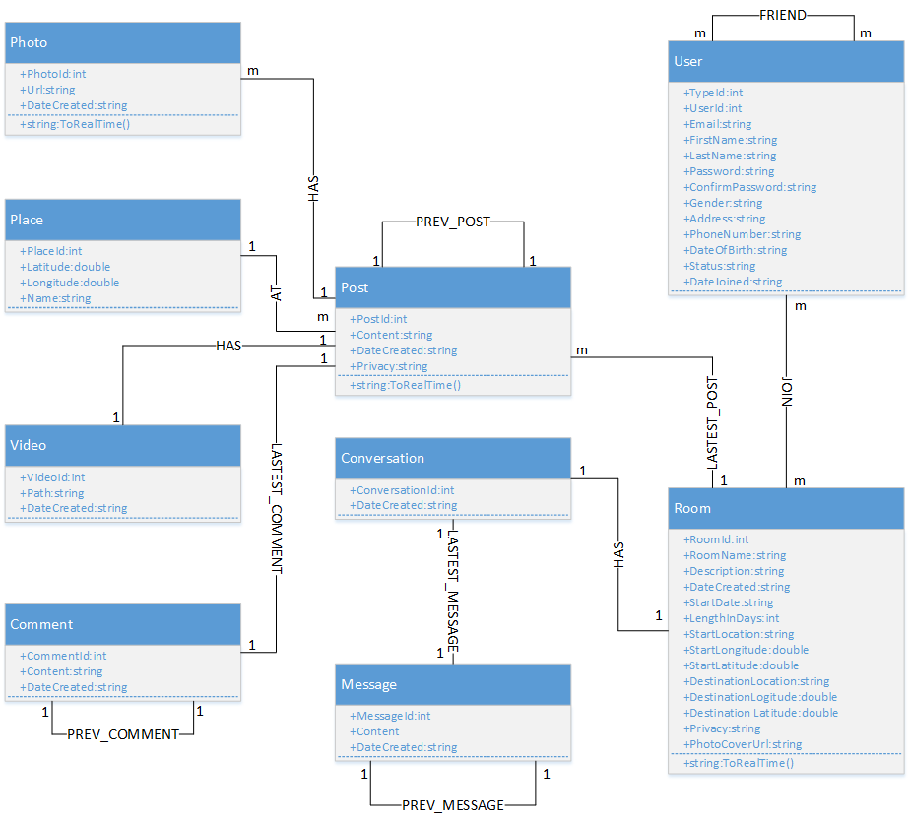

Entity Relationship Diagram part 1

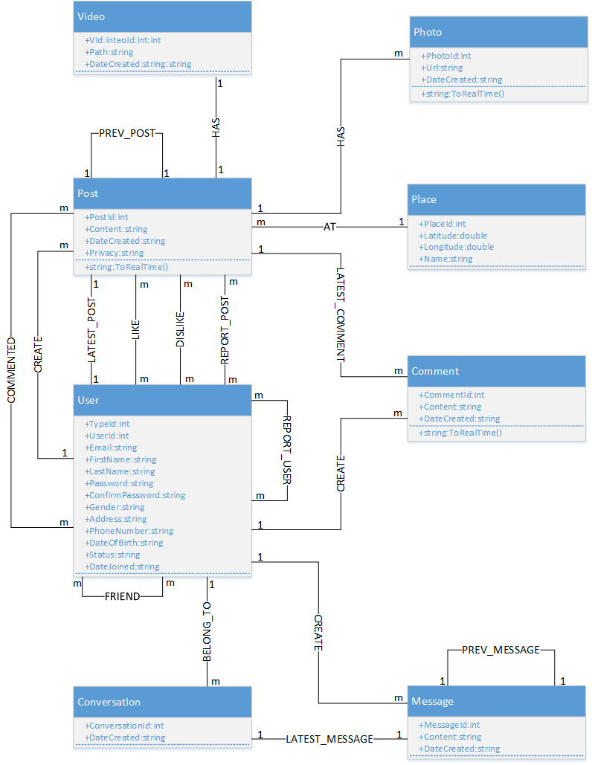

Entity Relationship Diagram part 2

### Entity Detail

#### Place

|  |  |  |  |  |
| --- | --- | --- | --- | --- |
| No | Attribute | Type | Mandatory | Description |
|  | Place ID | Number | Y | Place’s id |
|  | Longitude | Number | Y | Place’s longitude |
|  | Latitude | Number | Y | Place’s latitude |

#### Chat

|  |  |  |  |  |
| --- | --- | --- | --- | --- |
| No | Field Name | Type | Mandatory | Description |
|  | Chat ID | Number | Y | Chat’s id |
|  | Content | String | Y | Chat’s content |
|  | Date Created | Date | Y | Chat’s date created |

#### Room

|  |  |  |  |  |
| --- | --- | --- | --- | --- |
| No | Field Name | Type | Mandatory | Description |
|  | Room ID | Number | Y | Room’s id |
|  | Room Name | String | Y | Room’s name |
|  | Date Created | Date | Y | Room’s date created |

#### Post

|  |  |  |  |  |
| --- | --- | --- | --- | --- |
| No | Field Name | Type | Mandatory | Description |
|  | Post ID | Number | Y | Post’s id |
|  | Content | String | Y | Post’s content |
|  | Date Created | String | Y | Post’s date created |

#### Picture

|  |  |  |  |  |
| --- | --- | --- | --- | --- |
| No | Field Name | Type | Default | Description |
|  | Picture ID | Number | Y | Picture’s id |
|  | Path | String | Y | Picture’s path |
|  | Date Created | Date | Y | Picture’s date created |

#### Video

|  |  |  |  |  |
| --- | --- | --- | --- | --- |
| No | Field Name | Type | Mandatory | Description |
|  | Video ID | Number | Y | Video’s id |
|  | Path | String | Y | Video’s path |
|  | Date_created | Date | Y | Video’s date created |

#### Comment

|  |  |  |  |  |
| --- | --- | --- | --- | --- |
| No | Field Name | Type | Mandatory | Description |
|  | Comment ID | Number | Y | Comment’s id |
|  | Content | String | Y | Comment’s content |
|  | Date Created | Date | Y | Comment’s date created |

#### User

|  |  |  |  |  |
| --- | --- | --- | --- | --- |
| No | Field Name | Type | Mandatory | Description |
|  | User ID | Number | Y | User’s id |
|  | First Name | String | Y | User’s first name |
|  | Last Name | String | Y | User’s last name |
|  | Email | String | Y | User’s email |
|  | Password | String | Y | User’s password |
|  | Address | String | Y | User’s address |
|  | Genre | String | Y | User’s genre |
|  | Phone Number | String |  | User’s phone number |
|  | Date of Birth | Date | Y | User’s date of birth |
|  | Username | String | Y | User’s username |
|  | Status | String | Y | User’s status |
|  | Date Joined | Date | Y | User’s date joined |
|  | Type | String | Y | User’s type |

# **FUNCTIONAL SPECIFICATION**

## Business Rules

|  |  |
| --- | --- |
| **No** | **Description** |
|  | Search textbox cannot be empty |
|  | Subject cannot be empty |
|  | Content cannot be empty |
|  | Subject is limited to 1000 characters |
|  | Content is limited to 1000 characters |
|  | Allowed file extension: .jpg, .png, .bmp |
|  | File size is limited to 100 MB |
|  | Comment is limited to xxx characters |
|  | If user choose Others, textbox cannot be empty |
|  | Chat box cannot be empty |
|  | Friend must be chosen, cannot be entered |
|  | Name cannot be empty |
|  | Place must be chosen |
|  | Start date and end date must be chosen |
|  | Milestones must be chosen |
|  | Post lazy loading technique displays at most 10 each time |
|  | If user accesses to nonexistent page, FAP displays error message “Page not found” |
|  | User name must be at least xxx characters |
|  | Password must be at least xxx characters |
|  | Password cannot be same as user name |
|  | Email must content characters ‘@’ and ‘.’ |
|  | Date of birth must be chosen |
|  | Phone number must be number phrase |
|  | Locked user cannot comment |
|  | Locked user cannot create post |
|  | Information of each item in friend list includes: avatar (profile picture), friend name, “User” menu |
|  | Friend request has 3 states: “pending”, “accepted”, “declined” |
|  | The target user must be available, not locked or deleted |
|  | User mouse over menu includes: avatar (profile picture), user name, “User” menu |
|  | Room’s privacy is default set to Public |
|  | Milestones default status is Not passed |
|  | Allowed file extension: avi, mp4, flv |
|  | File size is limited to 100 MB |

## Use Cases

### Common Module

#### Search

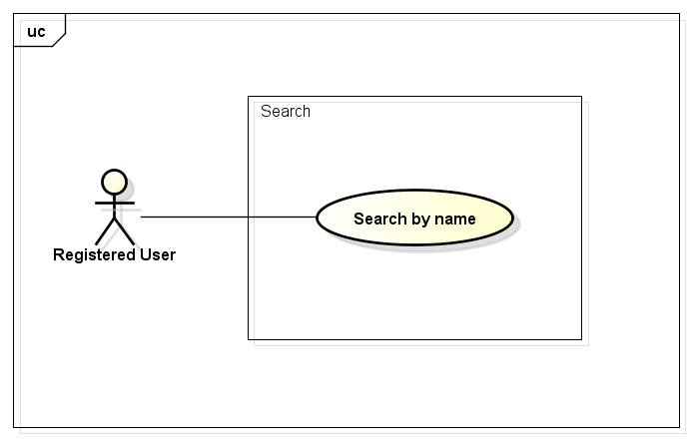

##### UC001-Search

|  |  |  |  |  |
| --- | --- | --- | --- | --- |
| **Use Case ID** | | UC001 | **Version** | 1.1 |
| **Use Case Name** | | Search by name | | |
| **Created by:** | | HieuTM | **Date Created:** | 28/05/2015 |
| **Primary Actor** | | Registered user | **Secondary Actor** |  |
| **Description:** | | This function allows user to search existing information stored on FAP by a phrase (name of places, food and drinks, activities, friends…) | | |
| **Preconditions:** | | 1. FAP website is available 2. User browsed FAP website 3. User is logged in to FAP | | |
| **Trigger:** | | User enters search phrase and click Search or press Enter | | |
| **Post conditions:** | | List all results that matched with the keyword user enters will be displayed in the Search Details screen | | |
| **Normal Flow** | | | | |
| **Step** | **Actor** | **Action** | | |
| 1 | User | Enter search phrase to text box | | |
| 2 | User | Click Search or press Enter | | |
| 3 | FAP | Redirect to Search Result screen includes   * Header * Room tab * People tab * Place tab | | |
| 4 | FAP | List all results that matched with the keyword user entered | | |
| **Alternative Flows:** | | | | |
| **AT1** | At step 2 in the main flows, if user click other hyperlinks or buttons | | | |
| **Step** | **Actor** | **Action** | | |
| 2.1 | FAP | Redirects user to chosen hyperlink or button | | |
|  | | | | |
| **Exceptions: N/A** | | | | |
| **Priority** | | High | | |
| **Frequency of Use:** | | High | | |
| **Business Rules:** | | B1 | | |
| **Other Information:** | | N/A | | |

#### Help Center

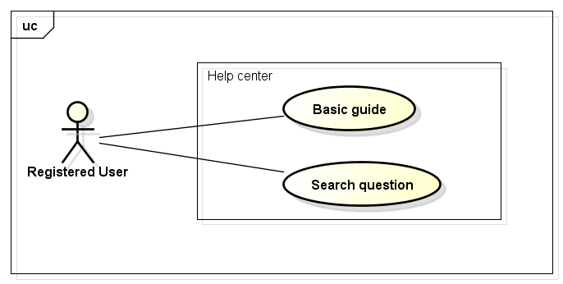

##### UC002-Basic Guide

|  |  |  |  |  |
| --- | --- | --- | --- | --- |
| **Use Case ID** | | UC002 | **Version** | 1.1 |
| **Use Case Name** | | Basic guide | | |
| **Created by:** | | HieuTM | **Date Created:** | 09/06/2015 |
| **Primary Actor** | | Registered user | **Secondary Actor** |  |
| **Description:** | | A guide page to let user know how to use FAP website or frequently asked questions. | | |
| **Preconditions:** | | 1. FAP website is available 2. User browsed FAP website 3. User is logged in to FAP | | |
| **Trigger:** | | User click Basic Guide in FAP website footer | | |
| **Post conditions:** | | FAP display Basic Guide page | | |
| **Normal Flow** | | | | |
| **Step** | **Actor** | **Action** | | |
| 1 | User | Click Basic Guide | | |
| 2 | FAP | Redirect user to Basic Guide page includes:   * Header * Search textbox * Search button * FAQ paragraphs | | |
| **Alternative Flows: N/A** | | | | |
| **Exceptions: N/A** | | | | |
| **Priority** | | Normal | | |
| **Frequency of Use:** | | Normal | | |
| **Business Rules:** | | N/A | | |
| **Other Information:** | | N/A | | |

##### UC003-Search Question

|  |  |  |  |  |
| --- | --- | --- | --- | --- |
| **Use Case ID** | | UC003 | **Version** | 1.1 |
| **Use Case Name** | | Search question | | |
| **Created by:** | | HieuTM | **Date Created:** | 09/06/2015 |
| **Primary Actor** | | Registered user | **Secondary Actor** |  |
| **Description:** | | This function allows user to search a question in frequently asked questions list | | |
| **Preconditions:** | | 1. FAP website is available 2. User browsed FAP website 3. User is logged in FAP 4. User browsed Basic Guide page | | |
| **Trigger:** | | User enters search phrase and click Search while in Basic Guide page | | |
| **Post conditions:** | | Question is displayed | | |
| **Normal Flow** | | | | |
| **Step** | **Actor** | **Action** | | |
| 1 | User | Enter search phrase to text box | | |
| 2 | User | Click Search or press Enter | | |
| 3 | FAP | Redirect user to question | | |
| **Alternative Flows: N/A** | | | | |
| **Exceptions:** | | | | |
| **EC1** | At step 3 in the main flows, if there is no result matched the keywords | | | |
| **Step** | **Actor** | **Action** | | |
| 3.1 | FAP | Display Basic Guide page with text: “Nothing found :(” | | |
|  | | | | |
| **Priority** | | Normal | | |
| **Frequency of Use:** | | Normal | | |
| **Business Rules:** | | N/A | | |
| **Other Information:** | | N/A | | |

### Suggest Module

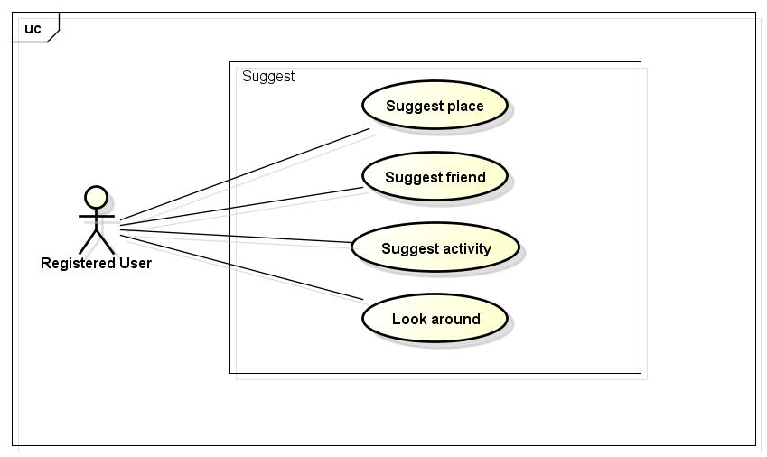

#### UC004-Suggest place

|  |  |  |  |  |
| --- | --- | --- | --- | --- |
| **Use Case ID** | | UC004 | **Version** | 1.1 |
| **Use Case Name** | | Suggest place | | |
| **Created by:** | | HieuTM | **Date Created:** | 09/06/2015 |
| **Primary Actor** | | Registered user | **Secondary Actor** | N/A |
| **Description:** | | FAP suggests places to user base on users traveled, viewed history, wish list and trends. | | |
| **Preconditions:** | | 1. FAP website is available 2. User browsed FAP website 3. User logged in to system 4. User is viewing Homepage or Personal Page | | |
| **Trigger:** | | User browses FAP website | | |
| **Post conditions:** | | 1. Suggests is displayed | | |
| **Normal Flow** | | | | |
| **Step** | **Actor** | **Action** | | |
|  | User | Click a post thumbnail | | |
|  | FAP | Display Suggest Place menu includes:   * Place menu item | | |
| **Alternative Flows: N/A** | | | | |
| **Exceptions: N/A** | | | | |
| **Priority** | | High | | |
| **Frequency of Use:** | | High | | |
| **Business Rules:** | | N/A | | |
| **Other Information:** | | N/A | | |

#### UC005-Suggest friend

|  |  |  |  |  |
| --- | --- | --- | --- | --- |
| **Use Case ID** | | UC005 | **Version** | 1.1 |
| **Use Case Name** | | Suggest friend | | |
| **Created by:** | | HieuTM | **Date Created:** | 09/06/2015 |
| **Primary Actor** | | Registered user | **Secondary Actor** | N/A |
| **Description:** | | FAP suggests friends to user base on mutual friends, activities or likes | | |
| **Preconditions:** | | 1. FAP website is available 2. User browsed FAP website 3. User logged in to system 4. User is viewing Homepage or Personal Page | | |
| **Trigger:** | | User browses FAP website | | |
| **Post conditions:** | | Suggests is displayed | | |
| **Normal Flow** | | | | |
| **Step** | **Actor** | **Action** | | |
| 1 | User | Click a post thumbnail | | |
| 2 | FAP | Display Suggest Friend menu includes:   * Friend menu item | | |
| **Alternative Flows: N/A** | | | | |
| **Exceptions: N/A** | | | | |
| **Priority** | | High | | |
| **Frequency of Use:** | | High | | |
| **Business Rules:** | | N/A | | |
| **Other Information:** | | N/A | | |

#### UC006-Suggest activity

|  |  |  |  |  |
| --- | --- | --- | --- | --- |
| **Use Case ID** | | UC006 | **Version** | 1.1 |
| **Use Case Name** | | Suggest activity | | |
| **Created by:** | | HieuTM | **Date Created:** | 09/06/2015 |
| **Primary Actor** | | Registered user | **Secondary Actor** | N/A |
| **Description:** | | FAP suggests activities to user base on users traveled, viewed history, wish list and trends. | | |
| **Preconditions:** | | 1. FAP website is available 2. User browsed FAP website 3. User logged in to system 4. User is viewing Homepage | | |
| **Trigger:** | | User clicks Hot Trends in Homepage | | |
| **Post conditions:** | | Suggests is displayed | | |
| **Normal Flow** | | | | |
| **Step** | **Actor** | **Action** | | |
| 1 | User | Click Hot Trends | | |
| 2 | FAP | Display Suggest Activity menu includes:   * Hot Trends menu item | | |
| **Alternative Flows: N/A** | | | | |
| **Exceptions: N/A** | | | | |
| **Priority** | | High | | |
| **Frequency of Use:** | | High | | |
| **Business Rules:** | | N/A | | |
| **Other Information:** | | N/A | | |

#### ~~UC007-Look around~~

|  |  |  |  |  |
| --- | --- | --- | --- | --- |
| **Use Case ID** | | UC007 | **Version** | 1.1 |
| **Use Case Name** | | Look around | | |
| **Created by:** | | HieuTM | **Date Created:** | 28/05/2015 |
| **Primary Actor** | | Registered user | **Secondary Actor** |  |
| **Description:** | | This function allows user to see activities of others around | | |
| **Preconditions:** | | 1. FAP website is available 2. User browsed FAP website 3. User logged in to system | | |
| **Trigger:** | | User click Look Around in header | | |
| **Post conditions:** | | 1. Look Around page is displayed | | |
| **Normal Flow** | | | | |
| **Step** | **Actor** | **Action** | | |
| 1 | User | Click Look Around | | |
| 2 | FAP | Redirect user to Look Around page includes:   * Header * Suggest Bar * Map * Post thumbnail and short description * Footer | | |
| 3 | User | Enter location to text box | | |
| 4 | User | Click Look or press Enter | | |
| 5 | FAP | Display Look Around page with results | | |
| **Alternative Flows** | | | | |
| **AT1** | At step 3 in the main flow, user click Auto-Located | | | |
| **Step** | **Actor** | **Action** | | |
| 3.1 | FAP | Display Look Around page with results | | |
|  | | | | |
| **AT2** | At step 4 in the main flows, if user click other hyperlinks or buttons | | | |
| **Step** | **Actor** | **Action** | | |
| 4.1 | FAP | Redirects user to chosen hyperlink or button | | |
|  | | | | |
| **Exceptions:** | | | | |
| **EC1** | The connection is terminated | | | |
| **Step** | **Actor** | **Action** | | |
| 1 | FAP | All fields are cleared and FAP return to the wait state. | | |
|  | | | | |
| **EC2** | At step 5 in the main flows, if there is no result matched the keywords | | | |
| **Step** | **Actor** | **Action** | | |
| 5.1 | FAP | Display Look Around page with message with ID MSG2 | | |
|  | | | | |
| **EC2** | At step 3.1 in the alternative flows, if FAP cannot locate user’s current location | | | |
| **Step** | **Actor** | **Action** | | |
| 3.1 | FAP | Display Look Around page with message with ID MSG3 | | |
|  | | | | |
| **Priority** | | Normal | | |
| **Frequency of Use:** | | High | | |
| **Business Rules:** | | N/A | | |
| **Other Information:** | | N/A | | |

### Social Module

#### Personal Page

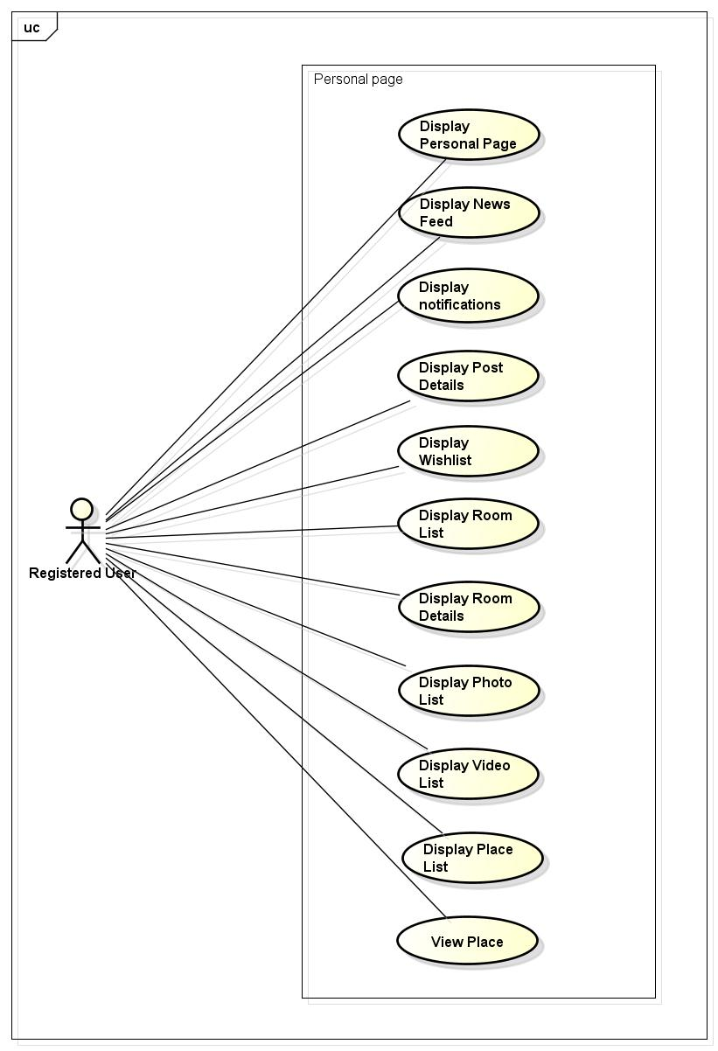

##### UC008-Display User’s Personal Page

|  |  |  |  |  |
| --- | --- | --- | --- | --- |
| **Use Case ID** | | UC008 | **Version** | 1.1 |
| **Use Case Name** | | Display Timeline | | |
| **Created by:** | | HieuTM | **Date Created:** | 28/05/2015 |
| **Primary Actor** | | Registered user | **Secondary Actor** |  |
| **Description:** | | FAP records all of user’s activities and display | | |
| **Preconditions:** | | 1. FAP website is available 2. User browsed FAP website 3. User logged in to system | | |
| **Trigger:** | | User click View Profile | | |
| **Post conditions:** | | Personal Page is displayed | | |
| **Normal Flow** | | | | |
| **Step** | **Actor** | **Action** | | |
| 1 | User | Click Avatar image button in header | | |
| 2 | FAP | Display a menu includes:   * View Profile menu item * Logout menu item | | |
| 3 | User | Click View Profile | | |
| 4 | FAP | Redirect user to Profile page includes:   * Header * Cover image label * Profile panel * Friend panel * Post thumbnails * Chat button | | |
| **Alternative Flows: N/A** | | | | |
| **Exceptions: N/A** | | | | |
| **Priority** | | High | | |
| **Frequency of Use:** | | High | | |
| **Business Rules:** | | N/A | | |
| **Other Information:** | | N/A | | |

##### UC009-Display Post list

|  |  |  |  |  |
| --- | --- | --- | --- | --- |
| **Use Case ID** | | UC009 | **Version** | 1.1 |
| **Use Case Name** | | Display Post list | | |
| **Created by:** | | HieuTM | **Date Created:** | 28/05/2015 |
| **Primary Actor** | | Registered user | **Secondary Actor** |  |
| **Description:** | | FAP updates activities of user’s friends automatically | | |
| **Preconditions:** | | 1. FAP website is available 2. User browsed FAP website 3. User logged in to system | | |
| **Trigger:** | | User browses FAP website and login | | |
| **Post conditions:** | | 1. Post list page is displayed | | |
| **Normal Flow** | | | | |
| **Step** | **Actor** | **Action** | | |
|  | FAP | Display Homepage page includes:   * Header * Suggest Bar * Post thumbnails | | |
| **Alternative Flows: N/A** | | | | |
| **Exceptions: N/A** | | | | |
| **Priority** | | High | | |
| **Frequency of Use:** | | High | | |
| **Business Rules:** | | N/A | | |
| **Other Information:** | | N/A | | |

##### UC010-Display Post Details

|  |  |  |  |  |
| --- | --- | --- | --- | --- |
| **Use Case ID** | | UC010 | **Version** | 1.1 |
| **Use Case Name** | | Display Post Details | | |
| **Created by:** | | ThuyLm | **Date Created:** | 28/05/2015 |
| **Primary Actor** | | Registered user | **Secondary Actor** |  |
| **Description:** | | FAP display details of a post | | |
| **Preconditions:** | | 1. FAP website is available 2. User browsed FAP website 3. User logged in to system 4. User is viewing Homepage or Personal Page | | |
| **Trigger:** | | User click post thumbnail | | |
| **Post conditions:** | | 1. A post is displayed | | |
| **Normal Flow** | | | | |
| **Step** | **Actor** | **Action** | | |
| 1 | User | Click a post thumbnail | | |
| 2 | FAP | Post Details page is displayed includes:   * Image/Photo of post * Place related to post * Owner of post * Like button * Dislike button * Add to wishlist button * Share button * Number of like, dislike, wishlist, shared * Comments * New comment panel | | |
| **Alternative Flows: N/A** | | | | |
| **Exceptions: N/A** | | | | |
| **Priority** | | High | | |
| **Frequency of Use:** | | High | | |
| **Business Rules:** | | N/A | | |
| **Other Information:** | | N/A | | |

##### UC011-Display Photo List

|  |  |  |  |  |
| --- | --- | --- | --- | --- |
| **Use Case ID** | | UC011 | **Version** | 1.1 |
| **Use Case Name** | | Display Photo List | | |
| **Created by:** | | ThuyLM | **Date Created:** | 28/05/2015 |
| **Primary Actor** | | Registered user | **Secondary Actor** |  |
| **Description:** | | FAP display all photo of an user | | |
| **Preconditions:** | | 1. FAP website is available 2. User browsed FAP website 3. User logged in to system | | |
| **Trigger:** | | User click Photos on Personal Page | | |
| **Post conditions:** | | 1. A list of photos is displayed | | |
| **Normal Flow** | | | | |
| **Step** | **Actor** | **Action** | | |
| 1 | User | Click Avatar image button in header | | |
| 2 | FAP | Display a menu includes:   * View Profile menu item * Logout menu item | | |
| 3 | User | Click View Profile | | |
| 4 | FAP | Redirect user to Profile page includes:   * Header * Cover image label * Profile panel * Friend panel * Post thumbnails * Chat button | | |
| 5 | User | Click Photos | | |
| 6 | FAP | Display list of photos | | |
| **Alternative Flows: N/A** | | | | |
| **Exceptions: N/A** | | | | |
| **Priority** | | High | | |
| **Frequency of Use:** | | High | | |
| **Business Rules:** | | N/A | | |
| **Other Information:** | | N/A | | |

##### UC012-Display Video List

|  |  |  |  |  |
| --- | --- | --- | --- | --- |
| **Use Case ID** | | UC012 | **Version** | 1.1 |
| **Use Case Name** | | Display Photo List | | |
| **Created by:** | | ThuyLM | **Date Created:** | 28/05/2015 |
| **Primary Actor** | | Registered user | **Secondary Actor** |  |
| **Description:** | | FAP display all video of an user | | |
| **Preconditions:** | | 1. FAP website is available 2. User browsed FAP website 3. User logged in to system | | |
| **Trigger:** | | User click Videos on Personal Page | | |
| **Post conditions:** | | 1. A list of videos is displayed | | |
| **Normal Flow** | | | | |
| **Step** | **Actor** | **Action** | | |
| 1 | User | Click Avatar image button in header | | |
| 2 | FAP | Display a menu includes:   * View Profile menu item * Logout menu item | | |
| 3 | User | Click View Profile | | |
| 4 | FAP | Redirect user to Profile page includes:   * Header * Cover image label * Profile panel * Friend panel * Post thumbnails * Chat button | | |
| 5 | User | Click Videos | | |
| 6 | FAP | Display list of Videos | | |
| **Alternative Flows: N/A** | | | | |
| **Exceptions: N/A** | | | | |
| **Priority** | | High | | |
| **Frequency of Use:** | | High | | |
| **Business Rules:** | | N/A | | |
| **Other Information:** | | N/A | | |

##### UC013-Display Place List

|  |  |  |  |  |
| --- | --- | --- | --- | --- |
| **Use Case ID** | | UC013 | **Version** | 1.1 |
| **Use Case Name** | | Display Place List | | |
| **Created by:** | | ThuyLM | **Date Created:** | 28/05/2015 |
| **Primary Actor** | | Registered user | **Secondary Actor** |  |
| **Description:** | | FAP display all place of an user | | |
| **Preconditions:** | | 1. FAP website is available 2. User browsed FAP website 3. User logged in to system | | |
| **Trigger:** | | User click Places on Personal Page | | |
| **Post conditions:** | | A list of places is displayed | | |
| **Normal Flow** | | | | |
| **Step** | **Actor** | **Action** | | |
| 1 | User | Click Avatar image button in header | | |
| 2 | FAP | Display a menu includes:   * View Profile menu item * Logout menu item | | |
| 3 | User | Click View Profile | | |
| 4 | FAP | Redirect user to Profile page includes:   * Header * Cover image label * Profile panel * Friend panel * Post thumbnails * Chat button | | |
| 5 | User | Click Places | | |
| 6 | FAP | Display list of places | | |
| **Alternative Flows: N/A** | | | | |
| **Exceptions: N/A** | | | | |
| **Priority** | | High | | |
| **Frequency of Use:** | | High | | |
| **Business Rules:** | | N/A | | |
| **Other Information:** | | N/A | | |

##### UC014-Display Notification

|  |  |  |  |  |
| --- | --- | --- | --- | --- |
| **Use Case ID** | | UC014 | **Version** | 1.1 |
| **Use Case Name** | | Display Notification | | |
| **Created by:** | | HieuTM | **Date Created:** | 28/05/2015 |
| **Primary Actor** | | Registered user | **Secondary Actor** |  |
| **Description:** | | FAP updates activities automatically and display notifications | | |
| **Preconditions:** | | 1. FAP website is available 2. User browsed FAP website 3. User logged in to system | | |
| **Trigger:** | | User click Notifications in Header | | |
| **Post conditions:** | | 1. Notification panel is displayed | | |
| **Normal Flow** | | | | |
| **Step** | **Actor** | **Action** | | |
| 1 | User | Click Notification | | |
| 2 | FAP | Notification panel is displayed includes:   * Notification label * Notification items * View All button | | |
| **Alternative Flows: N/A** | | | | |
| **AT1** | At step 1, user click Friends | | | |
| **Step** | **Actor** | **Action** | | |
| 1.1 | User | Click Friend | | |
| 1.2 | FAP | Friend panel is displayed include:   * Friend Request label * Friend Item: User name, Confirm button, Delete button   View All button | | |
|  | | | | |
| **AT2** | At step 1, user click Chat | | | |
| **Step** | **Actor** | **Action** | | |
| 1.1 | User | Click Chat | | |
| 1.2 | FAP | Chat menu is displayed includes:   * User menu item | | |
| 1.3 | User | Click a User menu item | | |
| 1.4 | FAP | Display Chat box | | |
|  | | | | |
| **Exceptions: N/A** | | | | |
| **Priority** | | High | | |
| **Frequency of Use:** | | High | | |
| **Business Rules:** | | N/A | | |
| **Other Information:** | | N/A | | |

##### UC015-View Place Details

|  |  |  |  |  |
| --- | --- | --- | --- | --- |
| **Use Case ID** | | UC015 | **Version** | 1.1 |
| **Use Case Name** | | View place | | |
| **Created by:** | | HieuTM | **Date Created:** | 28/05/2015 |
| **Primary Actor** | | Registered user | **Secondary Actor** |  |
| **Description:** | | FAP display post related to a place and place details | | |
| **Preconditions:** | | 1. FAP website is available 2. User browsed FAP website 3. User logged in to system | | |
| **Trigger:** | | User click Chat | | |
| **Post conditions:** | | 1. Homepage is displayed | | |
| **Normal Flow** | | | | |
| **Step** | **Actor** | **Action** | | |
| 1 | User | Click Place on corner of a post | | |
| 2 | FAP | Place details page is displayed includes:   * Location of place on Google maps * Basic information of places * Related post | | |
| **Alternative Flows: N/A** | | | | |
| **Exceptions:** | | | | |
| **EC1** | The connection is terminated | | | |
| **Step** | **Actor** | **Action** | | |
| 1 | FAP | Return to the wait state. | | |
|  | | | | |
| **Priority** | | High | | |
| **Frequency of Use:** | | High | | |
| **Business Rules:** | | N/A | | |
| **Other Information:** | | N/A | | |

#### Post management

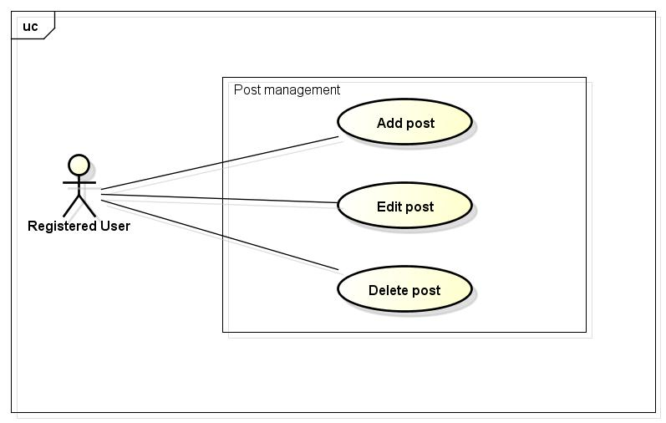

##### UC016-Add Post

|  |  |  |  |  |
| --- | --- | --- | --- | --- |
| **Use Case ID** | | UC016 | **Version** | 1.1 |
| **Use Case Name** | | Add post | | |
| **Created by:** | | HieuTM | **Date Created:** | 28/05/2015 |
| **Primary Actor** | | Registered user | **Secondary Actor** | None |
| **Description:** | | This function allows user to share information, knowledge, experience | | |
| **Preconditions:** | | 1. FAP website is available 2. User browsed FAP website 3. User logged in to system | | |
| **Trigger:** | | User click Create Post | | |
| **Post conditions:** | | 1. Post is updated to user’s Personal Page. 2. Post is updated to Post list of user’s friends. 3. Post is updated to Database. | | |
| **Normal Flow** | | | | |
| **Step** | **Actor** | **Action** | | |
|  | User | Click Create Post. | | |
|  | FAP | Create Post panel is displayed includes:   * Update Status label * Content text area * Location button * Photo button * Video button * Privacy dropdown button * Post button | | |
|  | User | Enter text into content text area | | |
|  | User | Click Place | | |
|  | FAP | Display Place panel | | |
|  | User | Enter whole or part of a place name | | |
|  | FAP | Display list of suggestion | | |
|  | User | Click a name in list of suggestion | | |
|  | User | Click Post or press Enter. | | |
|  | FAP | Create a post | | |
|  | FAP | Updates to user’s timeline | | |
|  | FAP | Updates to Post list of user’s friends | | |
|  | FAP | Redirects user to Post Detail page which contain created post. | | |
| **Alternative Flows** | | | | |
| **AT1** | At step 5 in the main flows, if user click out of Create Post panel | | | |
| **Step** | **Actor** | **Action** | | |
| 5.1 | FAP | Close Create Post panel | | |
|  | | | | |
| **AT2** | At step 1 in the main flows, if user choose Photos | | | |
| **Step** | **Actor** | **Action** | | |
| 1.1 | User | Click Create Post. | | |
| 1.2 | FAP | Create Post panel is displayed includes:   * Update Status label * Content text area * Location button * Photo button * Video button * Privacy dropdown button * Post button | | |
| 1.3 | User | Enter text into content text area | | |
|  | User | Click Place | | |
|  | FAP | Display Place panel | | |
|  | User | Enter whole or part of a place name | | |
|  | FAP | Display list of suggestion | | |
|  | User | Click a name in list of suggestion | | |
| 1.5 | User | Click Photo | | |
| 1.6 | FAP | Displays Add Photo panel | | |
| 1.7 | User | Click Add Photo button | | |
| 1.8 | FAP | Displays file chooser | | |
| 1.9 | User | Choose images | | |
| 1.10 | FAP | Displays images’ thumbnail | | |
| 1.11 | User | Click Create | | |
| 1.12 | FAP | Create a post | | |
| 1.13 | FAP | Updates to user’s timeline | | |
| 1.14 | FAP | Updates to Post list of user’s friends | | |
| 1.15 | FAP | Redirects user to Post Detail page which contain created post. | | |
|  | | | | |
| **AT3** | At step 1 in the main flows, if user choose Video | | | |
| **Step** | **Actor** | **Action** | | |
| 1.1 | User | Click Create Post. | | |
| 1.2 | FAP | Redirects user to Add Post Page includes:   * Header * Suggest Bar * Name textbox * Place textbox * Browse video button * Video link button * Privacy combo box * Description text area * Footer | | |
|  | User | Click Place | | |
|  | FAP | Display Place panel | | |
|  | User | Enter whole or part of a place name | | |
|  | FAP | Display list of suggestion | | |
|  | User | Click a name in list of suggestion | | |
| 1.3 | User | Click Add Video. | | |
| 1.4 | User | Redirects user to Add Video Page which contain an Add video form. | | |
| 1.5 | User | Click Browse to choose video. | | |
| 1.6 | FAP | Display video and Caption field | | |
| 1.7 | User | Enters information in fields. | | |
| 1.8 | User | User click Create or press Enter. | | |
| 1.9 | FAP | Create a post | | |
| 1.10 | FAP | Updates to user’s timeline | | |
| 1.11 | FAP | Updates to Post list of user’s friends | | |
| 1.12 | FAP | Displays message with ID MSG4 | | |
| 1.13 | FAP | Redirects user to Post Page which contain created post. | | |
| 1.14 | User | Click Create Post. | | |
| 1.15 | FAP | Redirects user to Add Post Page includes:   * Header * Suggest Bar * Name textbox * Place textbox * Browse video button * Video link button * Privacy combo box * Description text area   Footer | | |
|  | | | | |
| **Exceptions: N/A** | | | | |
| **EC1** | At step 5, Content text area is blank | | | |
| **Step** | **Actor** | **Action** | | |
| 5.1 | FAP | Display error message with ID MSG5 | | |
| 4.2 | FAP | Mark Content text area | | |
|  | | | | |
| **Priority** | | High | | |
| **Frequency of Use:** | | High | | |
| **Business Rules:** | | B25 | | |
| **Other Information:** | | N/A | | |

##### UC017-Edit Post

|  |  |  |  |  |
| --- | --- | --- | --- | --- |
| **Use Case ID** | | UC017 | **Version** | 1.1 |
| **Use Case Name** | | Edit post | | |
| **Created by:** | | HieuTM | **Date Created:** | 28/05/2015 |
| **Primary Actor** | | Registered user | **Secondary Actor** | None |
| **Description:** | | This function allows user to edit their post | | |
| **Preconditions:** | | 1. FAP website is available 2. User browsed FAP website 3. User logged in to system 4. User are viewing their own post | | |
| **Trigger:** | | User click Edit post while viewing an own post | | |
| **Post conditions:** | | 1. Post is updated to FAP website. 2. Post is updated to User Detail. 3. Post is updated to Database. | | |
| **Normal Flow** | | | | |
| **Step** | **Actor** | **Action** | | |
| 1 | User | Click Edit | | |
| 2 | FAP | Display Edit Post text box with old data | | |
| 3 | User | Edits data in text box. | | |
| 4 | User | Click Update or press Enter. | | |
| 5 | FAP | Edit this post | | |
| 6 | FAP | Displays message with ID MSG7 | | |
| 7 | FAP | Redirects user to Post Page which contain edited post. | | |
| **Alternative Flows** | | | | |
| **AT1** | At step 4, user click Cancel | | | |
| **Step** | **Actor** | **Action** | | |
| 4.1 | FAP | FAP redirects user to previous page. | | |
|  | | | | |
| **AT2** | At step 4 in the main flows, if user click out of Edit text box | | | |
| **Step** | **Actor** | **Action** | | |
| 4.1 | FAP | Edit text box is closed | | |
|  | | | | |
| **Exceptions:** | | | | |
| **EC1** | At step 4, if Edit text box is blank | | | |
| **Step** | **Actor** | **Action** | | |
| 4.1 | FAP | Display error message with ID MSG5 | | |
| 4.2 | FAP | Mark error fields | | |
|  | | | | |
| **Priority** | | Normal | | |
| **Frequency of Use:** | | High | | |
| **Business Rules:** | | N/A | | |
| **Other Information:** | | N/A | | |

##### UC018-Delete Post

|  |  |  |  |  |
| --- | --- | --- | --- | --- |
| **Use Case ID** | | UC018 | **Version** | 1.1 |
| **Use Case Name** | | Delete post | | |
| **Created by:** | | HieuTM | **Date Created:** | 28/05/2015 |
| **Primary Actor** | | Registered user | **Secondary Actor** | None |
| **Description:** | | This function allows user to delete what they posted | | |
| **Preconditions:** | | 1. FAP website is available 2. User browsed FAP website 3. User logged in to system 4. User are viewing their own post | | |
| **Trigger:** | | User click Delete while viewing a post | | |
| **Post conditions:** | | 1. Post is deleted in user’s Timeline. 2. Post status is updated to Database. | | |
| **Normal Flow** | | | | |
| **Step** | **Actor** | **Action** | | |
| 1 | User | Click Delete | | |
| 2 | FAP | Display confirm popup “Delete this post?” | | |
| 3 | User | Click OK | | |
| 4 | FAP | Delete this post | | |
| 5 | FAP | Redirects user to Homepage | | |
| **Alternative Flows** | | | | |
| **AT1** | At step 1, user click menu in bottom-right corner of a post thumbnail | | | |
| **Step** | **Actor** | **Action** | | |
| 3.1 | FAP | Display a menu includes:   * Edit menu item * Delete menu item | | |
| 3.2 | User | Click Delete | | |
| 3.3 | FAP | Display confirm popup “Delete this post?” | | |
| 3.4 | User | Click OK | | |
| 3.5 | FAP | Delete this post | | |
| 3.6 | FAP | Redirects user to Homepage | | |
|  | | | | |
| **AT1** | At step 3, user click Cancel | | | |
| **Step** | **Actor** | **Action** | | |
| 3.1 | FAP | Closes confirm popup | | |
| **Exceptions:** | | | | |
| **EC1** | The connection is terminated | | | |
| **Step** | **Actor** | **Action** | | |
| 1 | FAP | Return to the wait state. | | |
|  | | | | |
| **Priority** | | Normal | | |
| **Frequency of Use:** | | Low | | |
| **Business Rules:** | | N/A | | |
| **Other Information:** | | N/A | | |

#### Share

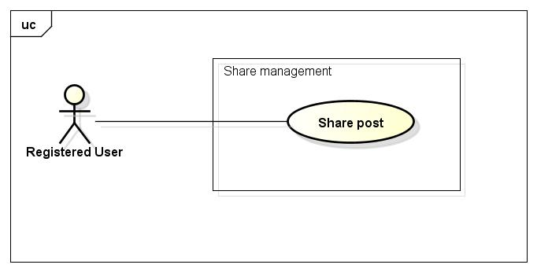

##### UC019-Share Post

|  |  |  |  |  |
| --- | --- | --- | --- | --- |
| **Use Case ID** | | UC019 | **Version** | 1.1 |
| **Use Case Name** | | Share post | | |
| **Created by:** | | HieuTM | **Date Created:** | 28/05/2015 |
| **Primary Actor** | | Registered user | **Secondary Actor** | None |
| **Description:** | | This function allows user to share a post, makes it available on timeline | | |
| **Preconditions:** | | 1. FAP website is available 2. User browsed FAP website 3. User logged in to system 4. User are viewing a post | | |
| **Trigger:** | | User click Share while viewing a post | | |
| **Post conditions:** | | 1. Shared post is updated to user’s Facebook timeline 2. Update share number of shared post | | |
| **Normal Flow** | | | | |
| **Step** | **Actor** | **Action** | | |
| 1 | User | Click Share. | | |
| 2 | FAP | Displays a textbox dialog. | | |
| 3 | User | Enters comment. | | |
| 4 | User | Click Share. | | |
| 5 | FAP | Closes dialog and updates shared post to user’s timeline. | | |
| **Alternative Flows** | | | | |
| **AT1** | At step 3, user click Cancel | | | |
| **Step** | **Actor** | **Action** | | |
| 3.1 | FAP | Closes confirm popup | | |
|  | | | | |
| **AT2** | At step 4 in the main flows, if user click other hyperlinks or buttons | | | |
| **Step** | **Actor** | **Action** | | |
| 4.1 | FAP | Redirects user to chosen hyperlink or button | | |
|  | | | | |
| **Exceptions:** | | | | |
| **EC1** | The connection is terminated | | | |
| **Step** | **Actor** | **Action** | | |
| 1 | FAP | All fields are cleared and FAP return to the wait state. | | |
|  | | | | |
| **Priority** | | High | | |
| **Frequency of Use:** | | High | | |
| **Business Rules:** | | N/A | | |
| **Other Information:** | | N/A | | |

#### Comment

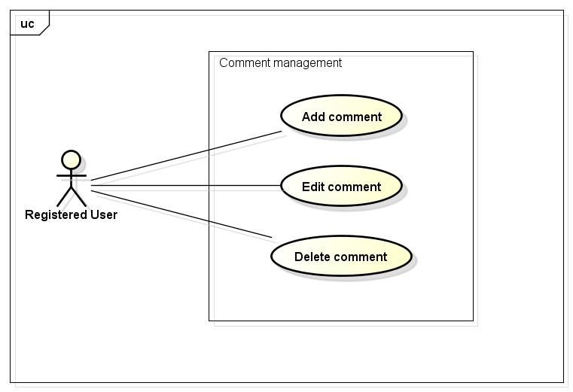

##### UC020-Add Comment

|  |  |  |  |  |
| --- | --- | --- | --- | --- |
| **Use Case ID** | | UC020 | **Version** | 1.1 |
| **Use Case Name** | | Add comment | | |
| **Created by:** | | HieuTM | **Date Created:** | 28/05/2015 |
| **Primary Actor** | | Registered user | **Secondary Actor** |  |
| **Description:** | | This function allows user to comment opinion in a post | | |
| **Preconditions:** | | 1. FAP website is available 2. User browsed FAP website 3. User logged in to system 4. User are viewing a post | | |
| **Trigger:** | | User enters comment and click Send while viewing a post | | |
| **Post conditions:** | | Updates post’s comments | | |
| **Normal Flow** | | | | |
| **Step** | **Actor** | **Action** | | |
|  | User | Entered comment into textbox | | |
|  | User | Click Send or press Enter | | |
|  | FAP | Updates post’s comment | | |
|  | FAP | Displays comment | | |
| **Alternative Flows:** | | | | |
| **AT1** | At step 2 in the main flows, if user click other hyperlinks or buttons | | | |
| **Step** | **Actor** | **Action** | | |
| 2.1 | FAP | Redirects user to chosen hyperlink or button | | |
|  | | | | |
| **AT2** | At step 2 in the main flows, if user click other hyperlinks or buttons | | | |
| **Step** | **Actor** | **Action** | | |
| 2.1 | FAP | Redirects user to chosen hyperlink or button | | |
|  | | | | |
| **Exceptions:** | | | | |
| **EC1** | The connection is terminated | | | |
| **Step** | **Actor** | **Action** | | |
| 1 | FAP | All fields are cleared and FAP return to the wait state. | | |
|  | | | | |
| **Priority** | | High | | |
| **Frequency of Use:** | | High | | |
| **Business Rules:** | | B8 B24 | | |
| **Other Information:** | | N/A | | |

##### UC021-Edit Comment

|  |  |  |  |  |
| --- | --- | --- | --- | --- |
| **Use Case ID** | | UC021 | **Version** | 1.1 |
| **Use Case Name** | | Edit comment | | |
| **Created by:** | | HieuTM | **Date Created:** | 28/05/2015 |
| **Primary Actor** | | Registered user | **Secondary Actor** |  |
| **Description:** | | This function allows user to edit what they commented | | |
| **Preconditions:** | | 1. FAP website is available 2. User browsed FAP website 3. User logged in to system 4. User are viewing a post has their own comments | | |
| **Trigger:** | | User click Edit while viewing an own comment | | |
| **Post conditions:** | | Updates post’s comments | | |
| **Normal Flow** | | | | |
| **Step** | **Actor** | **Action** | | |
|  | User | Click Edit | | |
|  | User | Displays a textbox | | |
|  | User | Entered comment into textbox | | |
|  | User | Click Edit or press Enter | | |
|  | FAP | Updates comment | | |
|  | FAP | Displays edited comment | | |
| **Alternative Flows:** | | | | |
| **AT1** | At step 4 in the main flows, if user click other hyperlinks or buttons | | | |
| **Step** | **Actor** | **Action** | | |
| 4.1 | FAP | Redirects user to chosen hyperlink or button | | |
|  | | | | |
| **AT2** | At step 4 in the main flows, if user click other hyperlinks or buttons | | | |
| **Step** | **Actor** | **Action** | | |
| 4.1 | FAP | Redirects user to chosen hyperlink or button | | |
|  | | | | |
| **Exceptions:** | | | | |
| **EC1** | The connection is terminated | | | |
| **Step** | **Actor** | **Action** | | |
| 1 | FAP | All fields are cleared and FAP return to the wait state. | | |
|  | | | | |
| **Priority** | | Normal | | |
| **Frequency of Use:** | | Normal | | |
| **Business Rules:** | | B8 | | |
| **Other Information:** | | N/A | | |

##### UC022-Delete Comment

|  |  |  |  |  |
| --- | --- | --- | --- | --- |
| **Use Case ID** | | UC022 | **Version** | 1.1 |
| **Use Case Name** | | Delete comment | | |
| **Created by:** | | HieuTM | **Date Created:** | 28/05/2015 |
| **Primary Actor** | | Registered user | **Secondary Actor** |  |
| **Description:** | | This function allows user to edit what they commented | | |
| **Preconditions:** | | 1. FAP website is available 2. User browsed FAP website 3. User logged in to system 4. User are viewing a post has their own comments | | |
| **Trigger:** | | User click Delete while viewing an own comment | | |
| **Post conditions:** | | 1. Post’s comment is deleted | | |
| **Normal Flow** | | | | |
| **Step** | **Actor** | **Action** | | |
|  | User | Click Delete | | |
|  | User | Displays confirm popup “Delete this comment?” | | |
|  | User | Click OK | | |
|  | User | Deletes comment | | |
|  | FAP | Display post without deleted comment | | |
| **Alternative Flows: N/A** | | | | |
| **Exceptions:** | | | | |
| **EC1** | The connection is terminated | | | |
| **Step** | **Actor** | **Action** | | |
| 1 | FAP | All fields are cleared and FAP return to the wait state. | | |
|  | | | | |
| **Priority** | | Normal | | |
| **Frequency of Use:** | | Low | | |
| **Business Rules:** | | N/A | | |
| **Other Information:** | | N/A | | |

#### Like

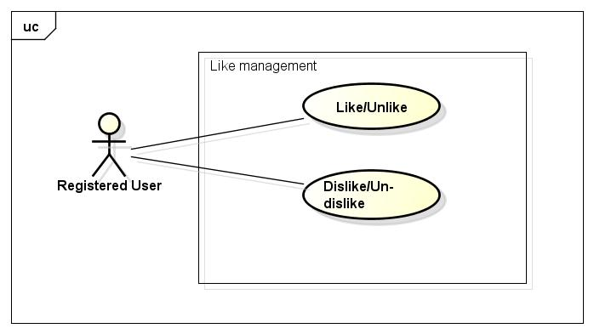

##### UC023-Like/Unlike

|  |  |  |  |  |
| --- | --- | --- | --- | --- |
| **Use Case ID** | | UC023 | **Version** | 1.1 |
| **Use Case Name** | | Like/Unlike | | |
| **Created by:** | | HieuTM | **Date Created:** | 28/05/2015 |
| **Primary Actor** | | Registered user | **Secondary Actor** |  |
| **Description:** | | This function allows user to rate a post or a comment | | |
| **Preconditions:** | | 1. FAP website is available 2. User browsed FAP website 3. User logged in to system 4. User are viewing a post or a comment | | |
| **Trigger:** | | User click Like while viewing a post or a comment | | |
| **Post conditions:** | | 1. Liked post is updated to user’s timeline 2. Liked post is updated to Post list of user’s friends if available 3. Update like number of liked post or comment | | |
| **Normal Flow** | | | | |
| **Step** | **Actor** | **Action** | | |
|  | User | Click Like | | |
|  | FAP | Updates liked post to user’s timeline | | |
|  | FAP | Updates liked post to Post list of user’s friends | | |
|  | FAP | Update like number of liked post | | |
|  | FAP | Displays post or comment as Liked | | |
| **Alternative Flows:** | | | | |
| **AT1** | User click Like a liked post | | | |
| **Step** | **Actor** | **Action** | | |
| 1 | User | Click Like | | |
| 3 | FAP | Update like number of liked post | | |
| 4 | FAP | Displays post or comment as normal | | |
| **Exceptions: N/A** | | | | |
| **Priority** | | High | | |
| **Frequency of Use:** | | High | | |
| **Business Rules:** | | N/A | | |
| **Other Information:** | | N/A | | |

##### UC024-Dislike/Un-dislike

|  |  |  |  |  |
| --- | --- | --- | --- | --- |
| **Use Case ID** | | UC024 | **Version** | 1.1 |
| **Use Case Name** | | Dislike | | |
| **Created by:** | | HieuTM | **Date Created:** | 28/05/2015 |
| **Primary Actor** | | Registered user | **Secondary Actor** |  |
| **Description:** | | This function allows user to rate a post or a comment | | |
| **Preconditions:** | | 1. FAP website is available 2. User browsed FAP website 3. User logged in to system 4. User are viewing a post or a comment | | |
| **Trigger:** | | User click Dislike a post or comment | | |
| **Post conditions:** | | 1. Dislike post is updated to user’s timeline 2. Dislike post is updated to Post list of user’s friends if available 3. Update dislike number of dislike post or comment | | |
| **Normal Flow** | | | | |
| **Step** | **Actor** | **Action** | | |
|  | User | Click Dislike | | |
|  | FAP | Updates dislike post to user’s timeline | | |
|  | FAP | Updates dislike post to Post list of user’s friends | | |
|  | FAP | Update dislike number of dislike post | | |
|  | FAP | Display post or comment as Disliked | | |
| **Alternative Flows: N/A** | | | | |
| **AT1** | User click Dislike a disliked post | | | |
| **Step** | **Actor** | **Action** | | |
| 1 | User | Click Dislike | | |
| 2 | FAP | Update dislike number of un-disliked of post | | |
| 3 | FAP | Unmark Dislike button | | |
|  | | | | |
| **Exceptions:** | | | | |
| **EC1** | The connection is terminated | | | |
| **Step** | **Actor** | **Action** | | |
| 1 | FAP | All fields are cleared and FAP return to the wait state. | | |
|  | | | | |
| **Priority** | | High | | |
| **Frequency of Use:** | | High | | |
| **Business Rules:** | | N/A | | |
| **Other Information:** | | N/A | | |

#### Report

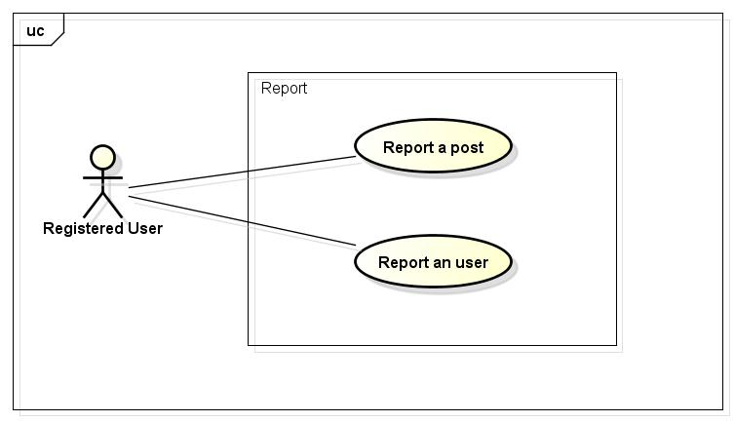

##### UC025-Report a post

|  |  |  |  |  |
| --- | --- | --- | --- | --- |
| **Use Case ID** | | UC025 | **Version** | 1.1 |
| **Use Case Name** | | Report a post | | |
| **Created by:** | | HieuTM | **Date Created:** | 28/05/2015 |
| **Primary Actor** | | Registered user | **Secondary Actor** |  |
| **Description:** | | This function allows user to report a post or comment violated rules | | |
| **Preconditions:** | | 1. FAP website is available 2. User browsed FAP website 3. User logged in to system 4. User are viewing a post or a comment | | |
| **Trigger:** | | User click Report while viewing a post | | |
| **Post conditions:** | | 1. Report is sent to admin | | |
| **Normal Flow** | | | | |
| **Step** | **Actor** | **Action** | | |
|  | User | Click Report. | | |
|  | FAP | Displays popup. | | |
|  | User | Choose common reason. | | |
|  | User | Click Report or press Enter. | | |
|  | FAP | Closes dialog. | | |
|  | FAP | Sent report to admin | | |
|  | FAP | Display message with ID MSG8 | | |
| **Alternative Flows** | | | | |
| **AT1** | At step 3, user choose Other: | | | |
| **Step** | **Actor** | **Action** | | |
| 3.1 | FAP | Displays a textbox dialog. | | |
| 3.2 | User | Enters reason into textbox. | | |
| 3.3 | User | Click Report or press Enter. | | |
| 3.4 | FAP | Closes dialog. | | |
| 3.5 | FAP | Sent report to admin | | |
| 3.6 | FAP | Display message with ID MSG8 | | |
|  | | | | |
| **AT2** | At step 4, user choose Cancel: | | | |
| **Step** | **Actor** | **Action** | | |
| 4.1 | FAP | Closes popup. | | |
|  | | | | |
| **AT3** | At step 4 in the main flows, if user click other hyperlinks or buttons | | | |
| **Step** | **Actor** | **Action** | | |
| 4.1 | FAP | Redirects user to chosen hyperlink or button | | |
|  | | | | |
| **Exceptions:** | | | | |
| **EC1** | The connection is terminated | | | |
| **Step** | **Actor** | **Action** | | |
| 1 | FAP | All fields are cleared and FAP return to the wait state. | | |
|  | | | | |
| **Priority** | | Normal | | |
| **Frequency of Use:** | | Normal | | |
| **Business Rules:** | | B3 B5 | | |
| **Other Information:** | | N/A | | |

##### UC026-Report a user

|  |  |  |  |  |
| --- | --- | --- | --- | --- |
| **Use Case ID** | | UC026 | **Version** | 1.1 |
| **Use Case Name** | | Report an user | | |
| **Created by:** | | HieuTM | **Date Created:** | 28/05/2015 |
| **Primary Actor** | | Registered user | **Secondary Actor** |  |
| **Description:** | | This function allows user to report an user who violated rules | | |
| **Preconditions:** | | 1. FAP website is available 2. User browsed FAP website 3. User logged in to system 4. User are viewing a post or a comment | | |
| **Trigger:** | | User click Report in User menu | | |
| **Post conditions:** | | 1. Report is sent to admin | | |
| **Normal Flow** | | | | |
| **Step** | **Actor** | **Action** | | |
|  | User | Click a User name. | | |
|  | FAP | Displays a menu includes these hyperlinks:   * Add Friend * Unfriend * Edit Relationship * Follow * Block * Report | | |
|  | User | Click Report. | | |
|  | FAP | Displays popup. | | |
|  | User | Choose common reason. | | |
|  | User | Click Report or press Enter. | | |
|  | FAP | Closes dialog. | | |
|  | FAP | Sent report to admin | | |
|  | FAP | Display message with ID MSG16 | | |
| **Alternative Flows** | | | | |
| **AT1** | At step 3, user choose Other: | | | |
| **Step** | **Actor** | **Action** | | |
| 3.1 | FAP | Displays a textbox dialog. | | |
| 3.2 | User | Enters reason into textbox. | | |
| 3.3 | User | Click Report or press Enter. | | |
| 3.4 | FAP | Closes dialog. | | |
| 3.5 | FAP | Sent report to admin | | |
| 3.6 | FAP | Display message with ID MSG8 | | |
|  | | | | |
| **AT3** | At step 4, user choose Cancel: | | | |
| **Step** | **Actor** | **Action** | | |
| 4.1 | FAP | Closes popup. | | |
| **Exceptions:** | | | | |
| **EC1** | The connection is terminated | | | |
| **Step** | **Actor** | **Action** | | |
| 1 | FAP | All fields are cleared and FAP return to the wait state. | | |
|  | | | | |
| **Priority** | | Normal | | |
| **Frequency of Use:** | | Normal | | |
| **Business Rules:** | | B3 B5 | | |
| **Other Information:** | | N/A | | |

#### Chat

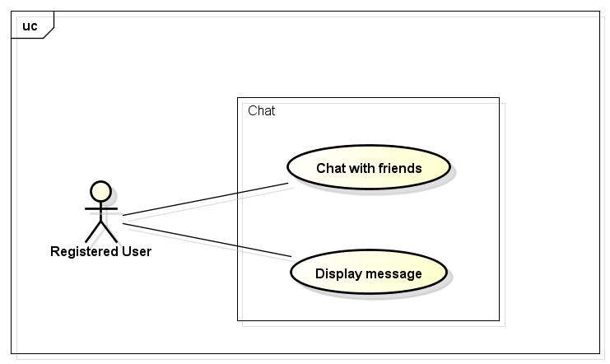

##### UC027-Display Message

|  |  |  |  |  |
| --- | --- | --- | --- | --- |
| **Use Case ID** | | UC027 | **Version** | 1.1 |
| **Use Case Name** | | Display Message | | |
| **Created by:** | | HieuTM | **Date Created:** | 28/05/2015 |
| **Primary Actor** | | Registered user | **Secondary Actor** |  |
| **Description:** | | FAP updates activities of user’s friends automatically | | |
| **Preconditions:** | | 1. FAP website is available 2. User browsed FAP website 3. User logged in to system | | |
| **Trigger:** | | User click Chat | | |
| **Post conditions:** | | 1. Chat panel is displayed | | |
| **Normal Flow** | | | | |
| **Step** | **Actor** | **Action** | | |
| 1 | User | Click Chat | | |
| 2 | FAP | Chat panel is displayed includes:   * User name | | |
| **Alternative Flows: N/A** | | | | |
| **Exceptions:** | | | | |
| **EC1** | The connection is terminated | | | |
| **Step** | **Actor** | **Action** | | |
| 1 | FAP | Return to the wait state. | | |
|  | | | | |
| **Priority** | | High | | |
| **Frequency of Use:** | | High | | |
| **Business Rules:** | | N/A | | |
| **Other Information:** | | N/A | | |

##### UC028-Chat with Friends

|  |  |  |  |  |
| --- | --- | --- | --- | --- |
| **Use Case ID** | | UC028 | **Version** | 1.1 |
| **Use Case Name** | | Report a post | | |
| **Created by:** | | HieuTM | **Date Created:** | 28/05/2015 |
| **Primary Actor** | | Registered user | **Secondary Actor** |  |
| **Description:** | | This function allows user to report a post or comment violated rules | | |
| **Preconditions:** | | 1. FAP website is available 2. User browsed FAP website 3. User logged in to system | | |
| **Trigger:** | | User type message to chat box and click Send | | |
| **Post conditions:** | | 1. Chat contents is sent | | |
| **Normal Flow** | | | | |
| **Step** | **Actor** | **Action** | | |
|  | User | Click Chat. | | |
|  | FAP | Displays Chat menu includes:   * User name menu item. | | |
|  | User | Click User name menu item. | | |
|  | FAP | Displays chat box. | | |
|  | User | Enters message to chat box. | | |
|  | User | Click Send or press Enter. | | |
|  | FAP | Sends message to friend. | | |
|  | FAP | Displays message on chat box. | | |
| **Alternative Flows:** | | | | |
| **AT1** | At step 6 in the main flows, if user click other hyperlinks or buttons | | | |
| **Step** | **Actor** | **Action** | | |
| 6.1 | FAP | Redirects user to chosen hyperlink or button | | |
|  | | | | |
| **Exceptions:** | | | | |
| **EC1** | The connection is terminated | | | |
| **Step** | **Actor** | **Action** | | |
| 1 | FAP | All fields are cleared and FAP return to the wait state. | | |
|  | | | | |
| **Priority** | | High | | |
| **Frequency of Use:** | | High | | |
| **Business Rules:** | | B10 | | |
| **Other Information:** | | N/A | | |

#### Friend management

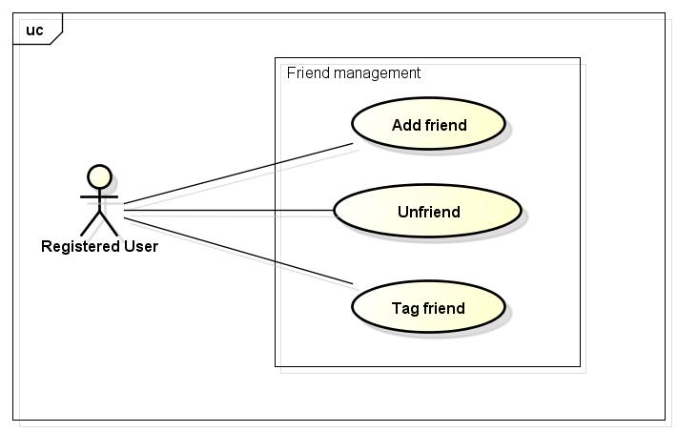

##### UC029-Add Friend

|  |  |  |  |  |
| --- | --- | --- | --- | --- |
| **Use Case ID** | | UC029 | **Version** | 1.1 |
| **Use Case Name** | | Add friend | | |
| **Created by:** | | HieuTM | **Date Created:** | 28/05/2015 |
| **Primary Actor** | | Registered user | **Secondary Actor** |  |
| **Description:** | | This function allows user to add others to friend list to chat or see their activities and updates | | |
| **Preconditions:** | | 1. FAP website is available 2. User browsed FAP website 3. User logged in to system | | |
| **Trigger:** | | User click Add Friend in others’ Personal Page | | |
| **Post conditions:** | | 1. Friend request is sent | | |
| **Normal Flow** | | | | |
| **Step** | **Actor** | **Action** | | |
|  | User | Click a User name. | | |
|  | FAP | Redirect user to Profile page includes:   * Header * Cover image label * Profile panel * Friend panel * Post thumbnails * Chat button | | |
|  | User | Click Add Friend. | | |
|  | FAP | Sends request to user | | |
|  | FAP | Display Add Friend button as Friend Request Sent instead | | |
| **Alternative Flows** | | | | |
| **AT1** | At step 6, if user click Add Friend button in Friend Suggest menu in a Post Detail page | | | |
| **Step** | **Actor** | **Action** | | |
| 3.1 | User | Click Add Friend | | |
| 3.2 | FAP | Display Add Friend button as Friend Request Sent instead | | |
|  | | | | |
| **Exceptions: N/A** | | | | |
| **Priority** | | High | | |
| **Frequency of Use:** | | High | | |
| **Business Rules:** | | N/A | | |
| **Other Information:** | | N/A | | |

##### UC030-Unfriend

|  |  |  |  |  |
| --- | --- | --- | --- | --- |
| **Use Case ID** | | UC030 | **Version** | 1.1 |
| **Use Case Name** | | Unfriend | | |
| **Created by:** | | HieuTM | **Date Created:** | 28/05/2015 |
| **Primary Actor** | | Registered user | **Secondary Actor** |  |
| **Description:** | | This function allows user to remove others from friend list | | |
| **Preconditions:** | | 1. FAP website is available 2. User browsed FAP website 3. User logged in to system 4. User are viewing a post or a comment | | |
| **Trigger:** | | User click Unfriend in User menu | | |
| **Post conditions:** | | 1. Friend is removed from list | | |
| **Normal Flow** | | | | |
| **Step** | **Actor** | **Action** | | |
|  | User | Click a User name. | | |
|  | FAP | Displays a menu includes these hyperlinks:   * Add Friend * Unfriend * Edit Relationship * Follow * Block * Report | | |
|  | User | Click Unfriend. | | |
|  | FAP | Displays confirm popup “Unfriend this user?” | | |
|  | User | Click OK. | | |
|  | FAP | Closes popup. | | |
|  | FAP | Remove friend from list | | |
| **Alternative Flows** | | | | |
| **AT1** | At step 5, user choose Cancel: | | | |
| **Step** | **Actor** | **Action** | | |
| 5.1 | FAP | Closes popup. | | |
|  | | | | |
| **Exceptions:** | | | | |
| **EC1** | The connection is terminated | | | |
| **Step** | **Actor** | **Action** | | |
| 1 | FAP | All fields are cleared and FAP return to the wait state. | | |
|  | | | | |
| **Priority** | | High | | |
| **Frequency of Use:** | | High | | |
| **Business Rules:** | | N/A | | |
| **Other Information:** | | N/A | | |

##### UC031-Tag Friend on Post

|  |  |  |  |  |
| --- | --- | --- | --- | --- |
| **Use Case ID** | | UC031 | **Version** | 1.1 |
| **Use Case Name** | | Tag friend on post | | |
| **Created by:** | | HieuTM | **Date Created:** | 28/05/2015 |
| **Primary Actor** | | Registered user | **Secondary Actor** |  |
| **Description:** | | This function allows user to tag friends, let friend receive notification about post or comment they were tagged. | | |
| **Preconditions:** | | 1. FAP website is available 2. User browsed FAP website 3. User logged in to system 4. User are viewing Post Detail page | | |
| **Trigger:** | | User click Tag while creating a post | | |
| **Post conditions:** | | Notification is sent to tagged users | | |
| **Normal Flow** | | | | |
| **Step** | **Actor** | **Action** | | |
|  | User | Click Comment text box | | |
|  | User | Type “@” into text box | | |
|  | FAP | Display friend name suggestion | | |
|  | User | Click a friend name | | |
|  | FAP | Display friend name as hyperlink | | |
|  | FAP | Sends notifications to tagged friend | | |
| **Alternative Flows: N/A** | | | | |
| **Exceptions: N/A** | | | | |
| **Priority** | | High | | |
| **Frequency of Use:** | | High | | |
| **Business Rules:** | | N/A | | |
| **Other Information:** | | N/A | | |

#### Room

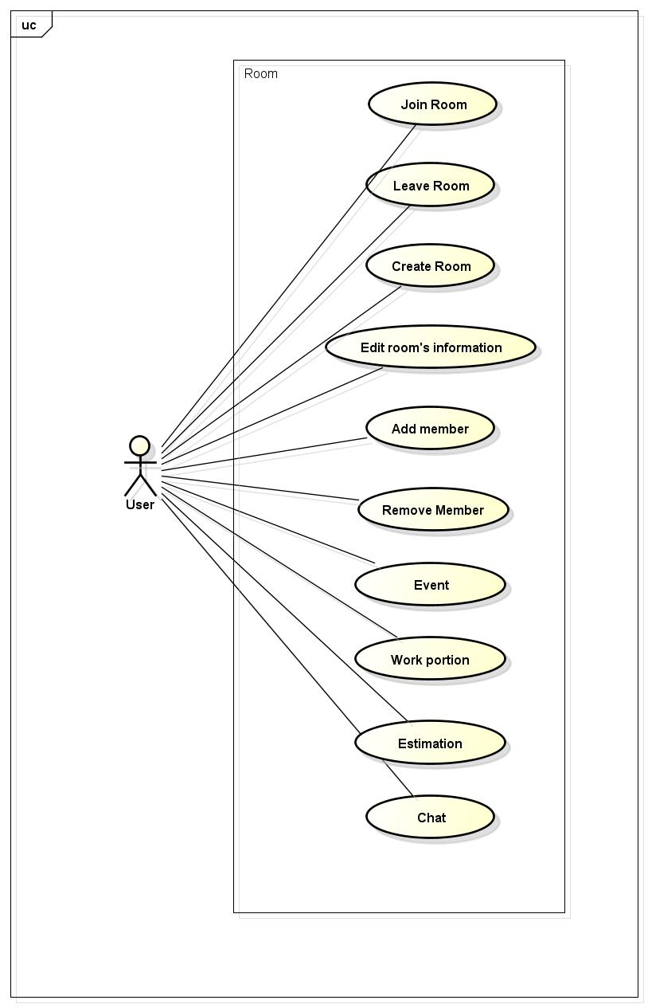

##### UC032-Join room

|  |  |  |  |  |
| --- | --- | --- | --- | --- |
| **Use Case ID** | | UC032 | **Version** | 1.0 |
| **Use Case Name** | | Join room | | |
| **Created by:** | | ThuyLM | **Date Created:** | 11/06/2015 |
| **Primary Actor** | | Registered user | **Secondary Actor** | None |
| **Description:** | | This function allows user join an existing room | | |
| **Preconditions:** | | 1. FAP must be connected to the Internet 2. User browsed FAP website 3. User logged in to system 4. Room have been existing | | |
| **Trigger:** | | User enters Room name and click Search | | |
| **Post conditions:** | | User join a room | | |
| **Normal Flow** | | | | |
| **Step** | **Actor** | **Action** | | |
|  | User | Click on Details button on Room thumbnail in Room list screen | | |
|  | FAP | Redirect user to Room Details screen | | |
| **Alternative Flows:** | | | | |
| **AT1** | At step 1, if Room is private | | | |
| **Step** | **Actor** | **Action** | | |
| 1.1 | User | Enter Room name on Search panel | | |
| 1.2 | User | Click Search or press Enter | | |
| 1.3 | FAP | Display Room on Search Result screen | | |
| 1.4 | User | Click on Details button on Room thumbnail in Search result page | | |
| 1.5 | FAP | Redirect user to Room Details screen | | |
|  | | | | |
| **AT2** | If user has been invited by a member of room | | | |
| **Step** | **Actor** | **Action** | | |
| 1.1 | FAP | Display notification to user | | |
| 1.2 | User | Click on invitation | | |
| 1.3 | FAP | Redirect user to Room Details screen | | |
| **Exceptions: N/A** | | | | |
| **Priority** | | High | | |
| **Frequency of Use:** | | High | | |
| **Business Rules:** | | None | | |
| **Other Information:** | | N/A | | |

##### UC033-Leave room

|  |  |  |  |  |
| --- | --- | --- | --- | --- |
| **Use Case ID** | | UC033 | **Version** | 1.0 |
| **Use Case Name** | | Leave room | | |
| **Created by:** | | ThuyLM | **Date Created:** | 11/06/2015 |
| **Primary Actor** | | Registered user | **Secondary Actor** |  |
| **Description:** | | This function allows users to leave a room that they have join | | |
| **Preconditions:** | | 1. FAP must be connected to the Internet 2. User browsed FAP website 3. User logged in to system 4. User has join a room | | |
| **Trigger:** | | User click Exit in Setting menu | | |
| **Post conditions:** | | 1. User is no longer on that room 2. Room has been deleted from user’s room list | | |
| **Normal Flow** | | | | |
| **Step** | **Actor** | **Action** | | |
|  | User | User enter Room page | | |
|  | User | Click on Setting button on Room Screen | | |
|  | User | Click “Exit” | | |
|  | FAP | 1. Redirect user to Homepage 2. Delete room name from user’s room list 3. Show message with ID MSG12 on Room Screen 4. Replace username on schedule/plan by “Left member” | | |
| **Alternative Flows: N/A** | | | | |
| **Exceptions: N/A** | | | | |
| **Priority** | | High | | |
| **Frequency of Use:** | | High | | |
| **Business Rules:** | | N/A | | |
| **Other Information:** | | N/A | | |

##### UC034-Create room

|  |  |  |  |  |
| --- | --- | --- | --- | --- |
| **Use Case ID** | | UC034 | **Version** | 1.0 |
| **Use Case Name** | | Create room | | |
| **Created by:** | | ThuyLM | **Date Created:** | 11/06/2015 |
| **Primary Actor** | | Registered user | **Secondary Actor** |  |
| **Description:** | | This function allows user to create new room | | |
| **Preconditions:** | | 1. FAP must be connected to the Internet 2. User browsed FAP website 3. User logged in to system | | |
| **Trigger:** | | User click Create Room in Homepage | | |
| **Post conditions:** | | A new room will be created | | |
| **Normal Flow** | | | | |
| **Step** | **Actor** | **Action** | | |
|  | User | Click Create a Room | | |
|  | FAP | Display a panel with fields and button:   * Room name * Room description * Start date * End date * Public/Private state * Start place * Target place * Create button | | |
|  | User | Fill information of room | | |
|  | User | Click “Create” | | |
|  | FAP | Create room | | |
|  | FAP | Redirect user to their new room | | |
| **Alternative Flows** | | | | |
| **AT1** | At step 5 in the main flows, user left Room name blank | | | |
| **Step** | **Actor** | **Action** | | |
| 5.1 | FAP | Display message with ID MSG13 | | |
| 5.2 | FAP | Return to step 4 | | |
|  | | | | |
| **Exceptions: N/A** | | | | |
| **Priority** | | High | | |
| **Frequency of Use:** | | High | | |
| **Business Rules:** | |  | | |
| **Other Information:** | | Not required fields will be filled with default value of FAP | | |

##### UC035-Edit room’s information

|  |  |  |  |  |
| --- | --- | --- | --- | --- |
| **Use Case ID** | | UC035 | **Version** | 1.0 |
| **Use Case Name** | | Edit room’s information | | |
| **Created by:** | | ThuyLM | **Date Created:** | 11/06/2015 |
| **Primary Actor** | | Registered user | **Secondary Actor** |  |
| **Description:** | | This function allow user edit room’s information | | |
| **Preconditions:** | | 1. FAP must be connected to the Internet 2. User browsed FAP website 3. User logged in to system 4. User created room | | |
| **Trigger:** | | User click Edit in Room Details screen | | |
| **Post conditions:** | | Room’s information is edited | | |
| **Normal Flow** | | | | |
| **Step** | **Actor** | **Action** | | |
|  | User | Click on button Edit on Room Details screen | | |
|  | FAP | Display a window with fields:   * Room name * Room description * Start date * End date * Public/Private state * Start place * Target place * Edit button | | |
|  | User | Edit room’s information | | |
|  | User | Click edit button | | |
|  | FAP | Redirect user to Room details screen | | |
|  | | | | |
| **Alternative Flows** | | | | |
| **AT1** | At step 5 in the main flows, user left Room name blank | | | |
| **Step** | **Actor** | **Action** | | |
| 5.1 | FAP | Display message with ID MSG13 | | |
| 5.2 | FAP | Return to step 4 | | |
|  | | | | |
| **AT2** | At step 3 in the main flow, user clicks on Cancel button | | | |
| **Step** | **Actor** | **Action** | | |
| 3.1 | FAP | Return to previous screen | | |
|  | | | | |
| **Exceptions: N/A** | | | | |
| **Priority** | | High | | |
| **Frequency of Use:** | | High | | |
| **Business Rules:** | |  | | |
| **Other Information:** | | N/A | | |

##### UC036-Create new event

|  |  |  |  |  |
| --- | --- | --- | --- | --- |
| **Use Case ID** | | UC036 | **Version** | 1.0 |
| **Use Case Name** | | Create milestones | | |
| **Created by:** | | ThuyLM | **Date Created:** | 11/06/2015 |
| **Primary Actor** | | Registered user | **Secondary Actor** |  |
| **Description:** | | This function allow user create milestone on their trips | | |
| **Preconditions:** | | 1. FAP must be connected to the Internet 2. User browsed FAP website 3. User logged in to system 4. User is administrator of room (creator of room) | | |
| **Trigger:** | | User click Personal Page in Room Details screen | | |
| **Post conditions:** | | New event be created | | |
| **Normal Flow** | | | | |
| **Step** | **Actor** | **Action** | | |
|  | User | Click on Personal Page on Room details screen | | |
|  | FAP | Display Personal Page | | |
|  | User | Select a hour on the calendar | | |
|  | FAP | Display a Add new event form include:   * Title * Date that user selected * Hour that user selected * Plan length (in hours) * Save button * Cancel button | | |
|  | User | Fill information | | |
|  | User | Click Save | | |
|  | FAP | Display new event on calendar | | |
| **Alternative Flows** | | | | |
| **AT1** | At step 3 in the main flow, user clicks on Cancel button | | | |
| **Step** | **Actor** | **Action** | | |
| 3.1 | FAP | Return to previous screen | | |
|  | | | | |
| **Exceptions: N/A** | | | | |
| **Priority** | | High | | |
| **Frequency of Use:** | | High | | |
| **Business Rules:** | |  | | |
| **Other Information:** | | N/A | | |

##### UC037-Edit event

|  |  |  |  |  |
| --- | --- | --- | --- | --- |
| **Use Case ID** | | UC037 | **Version** | 1.0 |
| **Use Case Name** | | Edit event | | |
| **Created by:** | | ThuyLM | **Date Created:** | 11/06/2015 |
| **Primary Actor** | | Registered user | **Secondary Actor** |  |
| **Description:** | | This function allow user edit an event of a trip on their room | | |
| **Preconditions:** | | 1. FAP must be connected to the Internet 2. User browsed FAP website 3. User logged in to system 4. User is administrator of room (creator of room) | | |
| **Trigger:** | | User click an existing event on Personal Page | | |
| **Post conditions:** | | Event is updated and display on Room details screen | | |
| **Normal Flow** | | | | |
| **Step** | **Actor** | **Action** | | |
|  | User | Click on Personal Page on Room details screen | | |
|  | FAP | Display Personal Page | | |
|  | User | Click on end time | | |
|  | User | Drag to the new end time | | |
|  | FAP | Display confirm popup | | |
|  | User | Click Yes | | |
|  | FAP | Save information and display on Plan panel | | |
| **Alternative Flows** | | | | |
| **AT1** | At step 6 in the main flow, user clicks on No button | | | |
| **Step** | **Actor** | **Action** | | |
| 3.1 | FAP | Event is not edited | | |
|  | | | | |
| **AT2** | At step 3 in the main flow, user clicks on event and drag it to other timespan | | | |
| **Step** | **Actor** | **Action** | | |
| 3.1 | FAP | Start time of event is move to the selected timespan | | |
|  | | | | |
| **Exceptions: N/A** | | | | |
| **Priority** | | High | | |
| **Frequency of Use:** | | High | | |
| **Business Rules:** | |  | | |
| **Other Information:** | | N/A | | |

##### UC037-Delete event

|  |  |  |  |  |
| --- | --- | --- | --- | --- |
| **Use Case ID** | | UC037 | **Version** | 1.0 |
| **Use Case Name** | | Delete event | | |
| **Created by:** | | ThuyLM | **Date Created:** | 11/06/2015 |
| **Primary Actor** | | Registered user | **Secondary Actor** |  |
| **Description:** | | This function allow user delete an event of a trip on their room | | |
| **Preconditions:** | | 1. FAP must be connected to the Internet 2. User browsed FAP website 3. User logged in to system 4. User is administrator of room (creator of room) | | |
| **Trigger:** | | User click an existing event on Personal Page | | |
| **Post conditions:** | | Event is updated and display on Room details screen | | |
| **Normal Flow** | | | | |
| **Step** | **Actor** | **Action** | | |
|  | User | Click on Personal Page on Room details screen | | |
|  | FAP | Display Personal Page | | |
|  | User | Right-click on end time | | |
|  | User | Select Delete | | |
|  | FAP | Delete event from calendar | | |
| **Alternative Flows: N/A** | | | | |
| **Exceptions: N/A** | | | | |
| **Priority** | | High | | |
| **Frequency of Use:** | | High | | |
| **Business Rules:** | |  | | |
| **Other Information:** | | N/A | | |

##### UC038-Add member

|  |  |  |  |  |
| --- | --- | --- | --- | --- |
| **Use Case ID** | | UC038 | **Version** | 1.0 |
| **Use Case Name** | | Add member | | |
| **Created by:** | | ThuyLM | **Date Created:** | 11/06/2015 |
| **Primary Actor** | | Registered user | **Secondary Actor** |  |
| **Description:** | | This function allows user add member to room | | |
| **Preconditions:** | | 1. FAP must be connected to the Internet 2. User browsed FAP website 3. User logged in to system 4. User is currently a member of room | | |
| **Trigger:** | | N/A | | |
| **Post conditions:** | | New member is added to room | | |
| **Normal Flow** | | | | |
| **Step** | **Actor** | **Action** | | |
|  | User | Tag name of friends on Add new member textbox | | |
|  | User | Click Add button | | |
|  | FAP | 1. Add new member to room and send notification to each people 2. Redirect user to Room details screen | | |
| **Alternative Flows** | | | | |
| **AT1** | At step 3 in the main flow, user clicks on Cancel button | | | |
| **Step** | **Actor** | **Action** | | |
| 3.1 | FAP | Return to previous screen | | |
|  | | | | |
| **Exceptions:** | | | | |
| **Priority** | | High | | |
| **Frequency of Use:** | | High | | |
| **Business Rules:** | |  | | |
| **Other Information:** | | N/A | | |

##### UC039-Add new task

|  |  |  |  |  |
| --- | --- | --- | --- | --- |
| **Use Case ID** | | UC039 | **Version** | 1.0 |
| **Use Case Name** | | Add new task | | |
| **Created by:** | | ThuyLM | **Date Created:** | 11/06/2015 |
| **Primary Actor** | | Registered user | **Secondary Actor** |  |
| **Description:** | | This function allows user add a new task for a trip | | |
| **Preconditions:** | | 1. FAP must be connected to the Internet 2. User browsed FAP website 3. User logged in to system 4. User is administrator of room (creator of room) | | |
| **Trigger:** | | User click General tab on Room Details screen | | |
| **Post conditions:** | | New task is updated | | |
| **Normal Flow** | | | | |
| **Step** | **Actor** | **Action** | | |
|  | User | Click on General tab on Room details screen | | |
|  | FAP | Display Tasks | | |
|  | User | Click on Add a room | | |
|  | FAP | Display a Add new task form include:   * Work portion * Note * Assign for * Start time * Plan length * Save button * Cancel button | | |
|  | User | Fill information | | |
|  | User | Click Save | | |
|  | FAP | Display new event on calendar | | |
| **Alternative Flows** | | | | |
| **AT2** | At step 3 in the main flow, user clicks on Cancel button | | | |
| **Step** | **Actor** | **Action** | | |
| 3.1 | FAP | Closes popup. | | |
|  | | | | |
| **Exceptions: N/A** | | | | |
| **Priority** | | High | | |
| **Frequency of Use:** | | High | | |
| **Business Rules:** | |  | | |
| **Other Information:** | | N/A | | |

##### UC040-Edit task

|  |  |  |  |  |
| --- | --- | --- | --- | --- |
| **Use Case ID** | | UC040 | **Version** | 1.0 |
| **Use Case Name** | | Edit task | | |
| **Created by:** | | ThuyLM | **Date Created:** | 11/06/2015 |
| **Primary Actor** | | Registered user | **Secondary Actor** |  |
| **Description:** | | This function allows user edit an existing task on General tabs | | |
| **Preconditions:** | | 1. FAP must be connected to the Internet 2. User browsed FAP website 3. User logged in to system 4. User is administrator of room (creator of room) | | |
| **Trigger:** | | User click General tab on Room Details screen | | |
| **Post conditions:** | | New task is updated | | |
| **Normal Flow** | | | | |
| **Step** | **Actor** | **Action** | | |
|  | User | Click on General tab on Room details screen | | |
|  | FAP | Display Tasks | | |
|  | User | Click on Menu bottom on right corner of a task | | |
|  | User | Select Edit | | |
|  | FAP | Display Edit task form include:   * Work portion * Note * Assign for * Start time * Plan length * Save button * Cancel button | | |
|  | User | Fill information | | |
|  | User | Click Save | | |
|  | FAP | Display edited task | | |
| **Alternative Flows** | | | | |
| **AT2** | At step 3 in the main flow, user clicks on Cancel button | | | |
| **Step** | **Actor** | **Action** | | |
| 3.1 | FAP | Closes popup. | | |
|  | | | | |
| **Exceptions: N/A** | | | | |
| **Priority** | | High | | |
| **Frequency of Use:** | | High | | |
| **Business Rules:** | |  | | |
| **Other Information:** | | N/A | | |

##### UC042-Delete task

|  |  |  |  |  |
| --- | --- | --- | --- | --- |
| **Use Case ID** | | UC042 | **Version** | 1.0 |
| **Use Case Name** | | Delete task | | |
| **Created by:** | | ThuyLM | **Date Created:** | 11/06/2015 |
| **Primary Actor** | | Registered user | **Secondary Actor** |  |
| **Description:** | | This function allow user delete an existing task of room | | |
| **Preconditions:** | | 1. FAP must be connected to the Internet 2. User browsed FAP website 3. User logged in to system 4. User is administrator of room (creator of room) | | |
| **Trigger:** | | Administrator of room approve the join request of other user | | |
| **Post conditions:** | | Task is deleted | | |
| **Normal Flow** | | | | |
| **Step** | **Actor** | **Action** | | |
|  | User | Click on | | |
|  | FAP | Display Tasks | | |
|  | User | Click on Menu bottom on right corner of a task | | |
|  | User | Select Delete | | |
|  | FAP | Display confirm pop-up | | |
|  | User | Click Yes | | |
|  | FAP | Delete task | | |
| **Alternative Flows** | | | | |
| **AT2** | At step 7 in the main flow, user clicks on Cancel button | | | |
| **Step** | **Actor** | **Action** | | |
| 3.1 | FAP | Closes popup. | | |
|  | | | | |
| **Exceptions: N/A** | | | | |
| **Priority** | | High | | |
| **Frequency of Use:** | | High | | |
| **Business Rules:** | |  | | |
| **Other Information:** | | N/A | | |

##### 1.1.1.1.1. UC042-Approve request

|  |  |  |  |  |
| --- | --- | --- | --- | --- |
| Use Case ID | | UC042 | Version | 1.0 |
| Use Case Name | | Approve request | | |
| Created by: | | ThuyLM | Date Created: | 11/06/2015 |
| Primary Actor | | Registered user | Secondary Actor |  |
| Description: | | This function allows administrator of a room approve member request | | |
| Preconditions: | | FAP must be connected to the Internet  User browsed FAP website  User logged in to system  User is administrator of room (creator of room) | | |
| Trigger: | | Administrator of room approve the join request of other user | | |
| Post conditions: | | New request is approved | | |
| Normal Flow | | | | |
| Step | Actor | Action | | |
|  | User | Click on Approve Request button on Room Details screen | | |
| 2 | FAP | Display list of request | | |
| 3 | User | Click on select box beside member request | | |
| 4 | User | Select Approve | | |
| 5 | FAP | Selected member is added to room | | |
| Alternative Flows | | | | |
| AT1 | At step 3 in the main flow, user clicks on Cancel button | | | |
| Step | Actor | Action | | |
| 3.1 | FAP | Closes popup. | | |
|  | | | | |
| AT2 | At step 4 in the main flow, user clicks on Decline button | | | |
| Step | Actor | Action | | |
| 3.1 | FAP | Decline member requests | | |
|  | | | | |
| Exceptions: N/A | | | | |
| Priority | | Low | | |
| Frequency of Use: | | Medium | | |
| Business Rules: | |  | | |
| Other Information: | | N/A | | |

##### UC043-Remove member

|  |  |  |  |  |
| --- | --- | --- | --- | --- |
| **Use Case ID** | | UC043 | **Version** | 1.0 |
| **Use Case Name** | | Remove member | | |
| **Created by:** | | ThuyLM | **Date Created:** | 11/06/2015 |
| **Primary Actor** | | Registered user | **Secondary Actor** |  |
| **Description:** | | This function allows user removes a member is already join the room | | |
| **Preconditions:** | | 1. FAP must be connected to the Internet 2. User browsed FAP website 3. User logged in to system 4. User is administrator of room (creator of room) | | |
| **Trigger:** | | User click Remove in Member menu | | |
| **Post conditions:** | | Member is removed from room | | |
| **Normal Flow** | | | | |
| **Step** | **Actor** | **Action** | | |
|  | User | Right click on Member profile picture on Member List | | |
|  | User | Choose Remove | | |
|  | FAP | 1. Delete this member from Member List 2. Send notification to member who had been remove from room | | |
| **Alternative Flows: N/A** | | | | |
| **Exceptions: N/A** | | | | |
| **Priority** | | High | | |
| **Frequency of Use:** | | High | | |
| **Business Rules:** | |  | | |
| **Other Information:** | | N/A | | |

##### UC041-Chat

|  |  |  |  |  |
| --- | --- | --- | --- | --- |
| **Use Case ID** | | UC041 | **Version** | 1.0 |
| **Use Case Name** | | Chat | | |
| **Created by:** | | ThuyLM | **Date Created:** | 11/06/2015 |
| **Primary Actor** | | Registered user | **Secondary Actor** |  |
| **Description:** | | This function allows user chat with all member on room | | |
| **Preconditions:** | | 1. FAP must be connected to the Internet 2. User browsed FAP website 3. User logged in to system 4. User is currently a member of room | | |
| **Trigger:** | | User type chat message to chat box and click Send | | |
| **Post conditions:** | | User can chat with all member on room | | |
| **Normal Flow** | | | | |
| **Step** | **Actor** | **Action** | | |
|  | User | Type a message on chat box | | |
|  | User | Click Send button or press Enter | | |
|  | FAP | Display message on chat windows; all member on room can see this message | | |
| **Alternative Flows: N/A** | | | | |
| **Exceptions: N/A** | | | | |
| **Priority** | | High | | |
| **Frequency of Use:** | | High | | |
| **Business Rules:** | |  | | |
| **Other Information:** | | N/A | | |

## Account Management Module

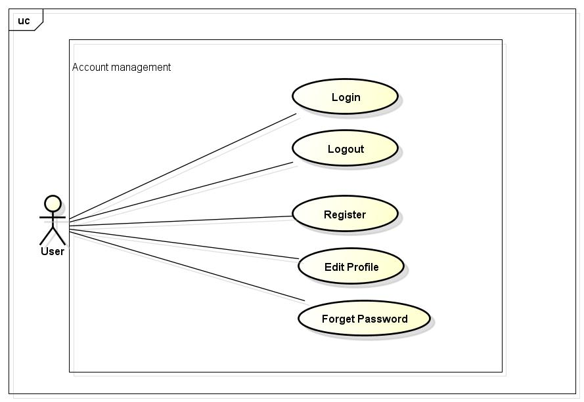

### Login

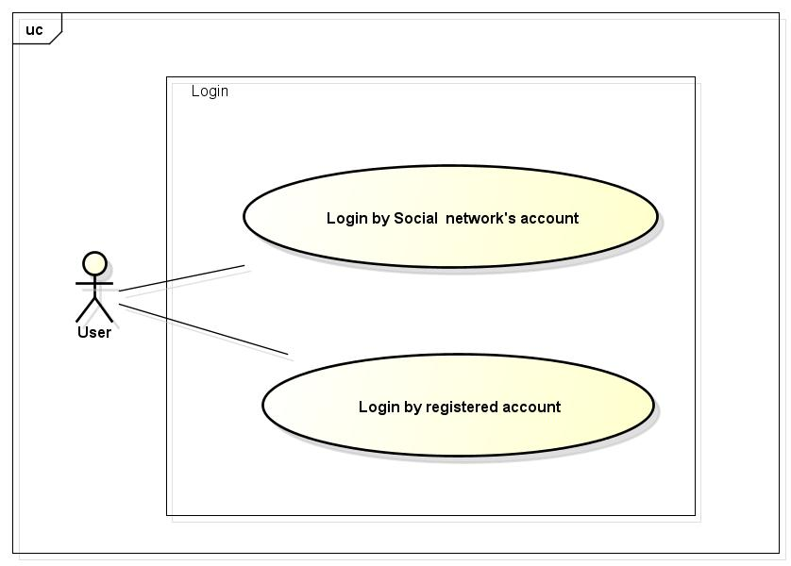

#### UC048-Login

|  |  |  |  |  |
| --- | --- | --- | --- | --- |
| **Use Case ID** | | UC048 | **Version** | 1.1 |
| **Use Case Name** | | Login by social network’s account  Login by registered account | | |
| **Created by:** | | LucPT | **Date Created:** | 28/05/2015 |
| **Primary Actor** | | Registered User | **Secondary Actor** |  |
| **Description:** | | When Member want to login by Facebook/Google/Register account to use more functions in website | | |
| **Preconditions:** | | 1. FAP must be connected to the Internet 2. User browsed FAP website 3. Account Facebook/Google/Register must be exist and correctly 4. User are viewing Login page | | |
| **Trigger:** | | User enter flyawayplus.com | | |
| **Post conditions:** | | 1. Log user into system 2. Redirect user to previous page and display as Member | | |
| **Normal Flow** | | | | |
| **Step** | **Actor** | **Action** | | |
|  | User | Click Login in Homepage | | |
|  | FAP | Display Login popup includes:   * User name text box * Password text box * Login button * Cancel button * Facebook button * Google+ button * Forgot password hyperlink | | |
|  | User | Enters User name and Password | | |
|  | User | Click Login | | |
|  | FAP | Logs user into system | | |
|  | FAP | Close popup | | |
|  | FAP | Display previous page as Member | | |
| **Alternative Flows** | | | | |
| **AT1** | At step 3 in the main flows, if user click Facebook or Google+ button | | | |
| **Step** | **Actor** | **Action** | | |
| 3.1 | FAP | Redirects user to confirm site | | |
| 3.2 | FAP | Logs user into system with Facebook or Google+ account | | |
|  | | | | |
| **AT2** | At step 4, user choose Cancel: | | | |
| **Step** | **Actor** | **Action** | | |
| 4.1 | FAP | Closes popup. | | |
|  | | | | |
| **AT3** | At step 8 in the main flows, if user click other hyperlinks or buttons | | | |
| **Step** | **Actor** | **Action** | | |
| 8.1 | FAP | Redirects user to chosen hyperlink or button | | |
|  | | | | |
| **Exceptions:** | | | | |
| **EC1** | At step 4 in main flow, if user entered wrong User name or Password | | | |
| **Step** | **Actor** | **Action** | | |
| 3.1 | FAP | Display Login popup message with ID MSG14 | | |
| 3.2 | FAP | Mark error fields | | |
|  | | | | |
| **Priority** | | High | | |
| **Frequency of Use:** | | High | | |
| **Business Rules:** | | N/A | | |
| **Other Information:** | | N/A | | |

### UC049-Logout

|  |  |  |  |  |
| --- | --- | --- | --- | --- |
| **Use Case ID** | | UC049 | **Version** | 1.1 |
| **Use Case Name** | | Logout | | |
| **Created by:** | | LucPT | **Date Created:** | 28/05/2015 |
| **Primary Actor** | | User | **Secondary Actor** |  |
| **Description:** | | When Member want to logout their account | | |
| **Preconditions:** | | 1. FAP must be connected to the Internet 2. User browsed FAP website 3. User logged in to system | | |
| **Trigger:** | | User click Logout in header | | |
| **Post conditions:** | | 1. Log user out from system. 2. Redirect user to login page | | |
| **Normal Flow** | | | | |
| **Step** | **Actor** | **Action** | | |
| 1 | User | Click Logout | | |
| 2 | FAP | Display page as Guest | | |
| **Alternative Flows: N/A** | | | | |
| **Exceptions: N/A** | | | | |
| **Priority** | | High | | |
| **Frequency of Use:** | | High | | |
| **Business Rules:** | | N/A | | |
| **Other Information:** | | N/A | | |

### UC050-Register

|  |  |  |  |  |  |
| --- | --- | --- | --- | --- | --- |
| **Use Case ID** | | | UC050 | **Version** | 1.1 |
| **Use Case Name** | | | Register | | |
| **Created by:** | | | LucPT | **Date Created:** | 28/05/2015 |
| **Primary Actor** | | | Guest | **Secondary Actor** |  |
| **Description:** | | | Visitor can create new account to use more function as a register user | | |
| **Preconditions:** | | | 1. FAP must be connected to the Internet 2. User browsed FAP website | | |
| **Trigger:** | | | Click on register link on the website | | |
| **Post conditions:** | | | 1. Add account information to database 2. Send confirm email 3. Logs user into system 4. Redirect user to Homepage and display as Member | | |
| **Normal Flow** | | | | | |
| **Step** | **Actor** | | **Action** | | |
|  | User | | Click Register in header | | |
|  | FAP | | Display Register page includes:   * Header * User name text box * Password text box * Email text box * Date of Birth date picker * Phone number text box * Register button * Cancel button | | |
|  | User | | Enters data in fields | | |
|  | User | | Click Register | | |
|  | FAP | | Send confirm email | | |
|  | FAP | | Logs user into system | | |
|  | FAP | | Display Homepage as Member | | |
| **Alternative Flows** | | | | | |
| **AT1** | At step 4, user click Cancel | | | | |
| **Step** | **Actor** | | **Action** | | |
| 4.1 | FAP | | Redirects user to previous page | | |
|  | | | | | |
| **AT2** | At step 4 in the main flows, if user click other hyperlinks or buttons | | | | |
| **Step** | **Actor** | **Action** | | | |
| 4.1 | FAP | Redirects user to chosen hyperlink or button | | | |
|  | | | | | |
| **Exceptions:** | | | | | |
| **EC1** | At step 4, required fields are not entered | | | | |
| **Step** | **Actor** | | **Action** | | |
| 4.1 | FAP | | Display Register page with message: with ID MSG5 | | |
| 4.2 | FAP | | Mark error fields | | |
|  | | | | | |
| **EC2** | At step 4, fields are entered with wrong type of data | | | | |
| **Step** | **Actor** | | **Action** | | |
| 4.1 | FAP | | Display Register page with message: with ID MSG6 | | |
| 4.2 | FAP | | Mark error fields | | |
|  | | | | | |
| **Priority** | | | High | | |
| **Frequency of Use:** | | | High | | |
| **Business Rules:** | | | B18 B19 B20 B21 B22 B23 | | |
| **Other Information:** | | | N/A | | |

### UC051-Edit profile

|  |  |  |  |  |  |
| --- | --- | --- | --- | --- | --- |
| **Use Case ID** | | UC051 | | **Version** | 1.1 |
| **Use Case Name** | | Edit profile | | | |
| **Created by:** | | LucPT | | **Date Created:** | 28/05/2015 |
| **Primary Actor** | | User/Admin | | **Secondary Actor** |  |
| **Description:** | | When user want to change their profile | | | |
| **Preconditions:** | | 1. FAP must be connected to the Internet 2. User browsed FAP website 3. User logged in to system | | | |
| **Trigger:** | | User click Edit profile while in Profile page | | | |
| **Post conditions:** | | 1. Edit information in database | | | |
| **Normal Flow** | | | | | |
| **Step** | **Actor** | **Action** | | | |
|  | User | Click Profile in header | | | |
|  | FAP | Display Profile page includes:   * Header * User profile panel * Footer | | | |
|  | User | Click Edit profile | | | |
|  | FAP | Display Profile page with data entered and editable fields | | | |
|  | User | Modifies fields | | | |
|  | User | Click OK | | | |
|  | FAP | Display Profile page with entered information | | | |
| **Alternative Flows** | | | | | |
| **AT2** | At step 3 in the main flow, user clicks on Cancel button | | | | |
| **Step** | **Actor** | **Action** | | | |
| 3.1 | FAP | Return to previous screen | | | |
|  | | | | | |
| **AT2** | At step 4 in the main flows, if user click other hyperlinks or buttons | | | | |
| **Step** | **Actor** | **Action** | | | |
| 4.1 | FAP | Redirects user to chosen hyperlink or button | | | |
|  | | | | | |
| **Exceptions:** | | | | | |
| **EC1** | At step 4, fields are entered with wrong type of data | | | | |
| **Step** | **Actor** | | **Action** | | |
| 4.1 | FAP | | Display Register page with message with ID MSG6 | | |
| 4.2 | FAP | | Mark error fields | | |
|  | | | | | |
| **Priority** | | High | | | |
| **Frequency of Use:** | | High | | | |
| **Business Rules:** | | B18 B19 B20 B21 B22 B23 | | | |
| **Other Information:** | | N/A | | | |

### UC052-Forgot password

|  |  |  |  |  |
| --- | --- | --- | --- | --- |
| **Use Case ID** | | UC052 | **Version** | 1.1 |
| **Use Case Name** | | Forgot password | | |
| **Created by:** | | LucPT | **Date Created:** | 28/05/2015 |
| **Primary Actor** | | User/admin | **Secondary Actor** |  |
| **Description:** | | When Member, Admin forgot their password to login the system, this function will receiving their password to email | | |
| **Preconditions:** | | 1. FAP must be connected to the Internet 2. User browsed FAP website 3. User logged in to system | | |
| **Trigger:** | | Click Forgot password in Login popup | | |
| **Post conditions:** | | 1. Send confirm email | | |
| **Normal Flow** | | | | |
| **Step** | **Actor** | **Action** | | |
|  | User | Click Forgot password in Login popup | | |
|  | FAP | Display Email text box | | |
|  | User | Enter registered email | | |
|  | User | Click OK | | |
|  | FAP | Sends confirm email | | |
|  | FAP | Close popup | | |
| **Alternative Flows** | | | | |
| **AT2** | At step 3 in the main flow, user clicks on Cancel button | | | |
| **Step** | **Actor** | **Action** | | |
| 3.1 | FAP | Return to previous screen | | |
|  | | | | |
| **AT2** | At step 4 in the main flows, if user click other hyperlinks or buttons | | | |
| **Step** | **Actor** | **Action** | | |
| 4.1 | FAP | Redirects user to chosen hyperlink or button | | |
|  | | | | |
| **Exceptions:** | | | | |
| **EC1** | At step 4, entered email is invalid | | | |
| **Step** | **Actor** | **Action** | | |
| 4.1 | FAP | Displays Login popup with message: with ID MSG15 | | |
| 4.2 | FAP | Marks email text box | | |
|  | | | | |
| **Priority** | | High | | |
| **Frequency of Use:** | | High | | |
| **Business Rules:** | | N/A | | |
| **Other Information:** | | N/A | | |

## Admin Module

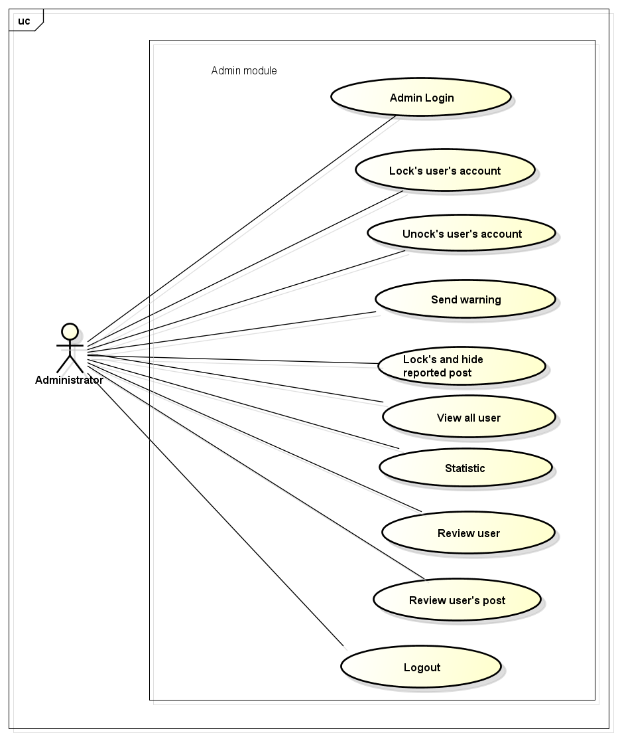

#### UC053-Login

|  |  |  |  |  |
| --- | --- | --- | --- | --- |
| **Use Case ID** | | UC053 | **Version** | 1.1 |
| **Use Case Name** | | Admin Login | | |
| **Created by:** | | LucPT | **Date Created:** | 28/05/2015 |
| **Primary Actor** | | Registered User | **Secondary Actor** |  |
| **Description:** | | When Administrator want to login to website | | |
| **Preconditions:** | | 1. FAP must be connected to the Internet 2. Admin browsed FAP website 3. Admin’s account must be exist and correctly 4. Admin are viewing Login page | | |
| **Trigger:** | | User enter flyawayplus.com | | |
| **Post conditions:** | | 1. Log admin into system 2. Redirect admin to Admin page. | | |
| **Normal Flow** | | | | |
| **Step** | **Actor** | **Action** | | |
| 1 | User | Admin enter flyawayplus.com/Admin | | |
| 2 | FAP | Display Login popup includes:   * User name text box * Password text box * Login button * Cancel button | | |
| 3 | User | Enters User name and Password | | |
| 4 | User | Click Login | | |
| 5 | FAP | Logs admin into system | | |
| 6 | FAP | Close popup | | |
| 7 | FAP | Display admin page | | |
| **Alternative Flows** | | | | |
| **AT1** | At step 4, admin choose Cancel: | | | |
| **Step** | **Actor** | **Action** | | |
| 4.1 | FAP | Closes popup. | | |
|  | | | | |
| **AT2** | At step 8 in the main flows, if user click other hyperlinks or buttons | | | |
| **Step** | **Actor** | **Action** | | |
| 8.1 | FAP | Redirects admin to chosen hyperlink or button | | |
|  | | | | |
| **Exceptions:** | | | | |
| **EC1** | At step 4 in main flow, if user entered wrong User name or Password | | | |
| **Step** | **Actor** | **Action** | | |
| 3.1 | FAP | Display Login popup message with ID MSG14 | | |
| 3.2 | FAP | Mark error fields | | |
|  | | | | |
| **Priority** | | High | | |
| **Frequency of Use:** | | High | | |
| **Business Rules:** | | N/A | | |
| **Other Information:** | | N/A | | |

### UC054-Logout

|  |  |  |  |  |
| --- | --- | --- | --- | --- |
| **Use Case ID** | | UC054 | **Version** | 1.1 |
| **Use Case Name** | | Logout | | |
| **Created by:** | | LucPT | **Date Created:** | 28/05/2015 |
| **Primary Actor** | | Administrator | **Secondary Actor** |  |
| **Description:** | | When Admin want to logout their account | | |
| **Preconditions:** | | 1. FAP must be connected to the Internet 2. User browsed FAP website 3. User logged in to system | | |
| **Trigger:** | | User click Logout in header | | |
| **Post conditions:** | | 1. Log admin out from system. 2. Redirect admin to login page. | | |
| **Normal Flow** | | | | |
| **Step** | **Actor** | **Action** | | |
| 1 | User | Click Logout | | |
| 2 | FAP | Display page as Guest | | |
| **Alternative Flows: N/A** | | | | |
| **Exceptions: N/A** | | | | |
| **Priority** | | High | | |
| **Frequency of Use:** | | High | | |
| **Business Rules:** | | N/A | | |
| **Other Information:** | | N/A | | |

### UC055-Lock user’s account

|  |  |  |  |  |
| --- | --- | --- | --- | --- |
| **Use Case ID** | | UC055 | **Version** | 1.1 |
| **Use Case Name** | | Lock user’s account | | |
| **Created by:** | | LucPT | **Date Created:** | 28/05/2015 |
| **Primary Actor** | | Admin | **Secondary Actor** | None |
| **Description:** | | Administrator can lock user account in a period of time depending on severity | | |
| **Preconditions:** | | 1. FAP must be connected to the Internet 2. User browsed FAP website 3. User logged into system as Admin | | |
| **Trigger:** | | User click Lock in User menu | | |
| **Post conditions:** | | 1. Chosen account is locked 2. Lock notification is sent 3. User’s status is updated to database | | |
| **Normal Flow** | | | | |
| **Step** | **Actor** | **Action** | | |
|  | User | Click a User name | | |
|  | FAP | Displays a menu includes these hyperlinks:   * Add Friend * Unfriend * Edit Relationship * Follow * Block * Lock * Warn | | |
|  | User | Click Lock | | |
|  | FAP | Displays message popup. | | |
|  | User | Enters text box into textbox. | | |
|  | User | Click Lock or press Enter | | |
|  | FAP | Closes popup. | | |
|  | FAP | Locks chosen account | | |
|  | FAP | Sends notification to locked account: “Your account has been locked” | | |
| **Alternative Flows** | | | | |
| **AT1** | At step 6 in the main flows, if user click Cancel | | | |
| **Step** | **Actor** | **Action** | | |
| 6.1 | FAP | Close popup | | |
|  | | | | |
| **Exceptions: N/A** | | | | |
| **Priority** | | High | | |
| **Frequency of Use:** | | High | | |
| **Business Rules:** | | N/A | | |
| **Other Information:** | | N/A | | |

### UC054-Unlock user’s account

|  |  |  |  |  |
| --- | --- | --- | --- | --- |
| **Use Case ID** | | UC054 | **Version** | 1.1 |
| **Use Case Name** | | Unlock user’s account | | |
| **Created by:** | | LucPT | **Date Created:** | 28/05/2015 |
| **Primary Actor** | | Admin | **Secondary Actor** |  |
| **Description:** | | Administrator can unlock user account | | |
| **Preconditions:** | | 1. FAP must be connected to the Internet 2. User browsed FAP website 3. User logged into system as Admin 4. Only locked user can be unlock | | |
| **Trigger:** | | User click Unlock in User menu | | |
| **Post conditions:** | | 1. Chosen account is unlocked 2. Unlock notification is sent 3. User’s status is updated to database | | |
| **Normal Flow** | | | | |
| **Step** | **Actor** | **Action** | | |
|  | User | Click Locked list | | |
|  | User | Click a User name in Locked list | | |
|  | FAP | Displays a menu includes these hyperlinks:   * Add Friend * Unfriend * Edit Relationship * Follow * Block * Unlock * Warn | | |
|  | User | Click Unlock | | |
|  | FAP | Display confirm popup: “Unlock this user?” | | |
|  | User | Click OK | | |
|  | FAP | Unlocks chosen account | | |
|  | FAP | Sends notification to unlocked account: “Your account has been unlocked” | | |
| **Alternative Flows:** | | | | |
| **AT1** | At step 6 in the main flows, if user click Cancel | | | |
| **Step** | **Actor** | **Action** | | |
| 6.1 | FAP | Close popup | | |
| **Exceptions: N/A** | | | | |
| **Priority** | | High | | |
| **Frequency of Use:** | | High | | |
| **Business Rules:** | | N/A | | |
| **Other Information:** | | N/A | | |

### UC055-Send warning

|  |  |  |  |  |
| --- | --- | --- | --- | --- |
| **Use Case ID** | | UC055 | **Version** | 1.1 |
| **Use Case Name** | | Send warning | | |
| **Created by:** | | LucPT | **Date Created:** | 28/05/2015 |
| **Primary Actor** | | Admin | **Secondary Actor** |  |
| **Description:** | | Administrator can warn user when they violate some rule of website but just quite small | | |
| **Preconditions:** | | 1. FAP must be connected to the Internet 2. User browsed FAP website 3. User logged into system as Admin | | |
| **Trigger:** | | User click Warn in User menu | | |
| **Post conditions:** | | 1. Warn is sent to user | | |
| **Normal Flow** | | | | |
| **Step** | **Actor** | **Action** | | |
| 1 | Admin | Click a User name | | |
| 2 | FAP | Displays a menu includes these hyperlinks:   * Add Friend * Unfriend * Edit Relationship * Follow * Block * Lock * Warn | | |
| 3 | Admin | Click Warn | | |
| 4 | FAP | Displays text box popup. | | |
| 5 | Admin | Enters message into textbox. | | |
| 6 | Admin | Click Warn or press Enter | | |
| 7 | FAP | Closes popup. | | |
|  |  | Locks chosen account | | |
|  |  | Sends notification to locked account: “Your account has been locked” | | |
| **Alternative Flows** | | | | |
| **AT1** | At step 6 in the main flows, if user click Cancel | | | |
| **Step** | **Actor** | **Action** | | |
| 6.1 | FAP | Close popup | | |
|  | | | | |
| **Exceptions: N/A** | | | | |
| **Priority** | | High | | |
| **Frequency of Use:** | | High | | |
| **Business Rules:** | | N/A | | |
| **Other Information:** | | N/A | | |

### UC056-Review user

|  |  |  |  |  |
| --- | --- | --- | --- | --- |
| **Use Case ID** | | UC056 | **Version** | 1.1 |
| **Use Case Name** | | Review user | | |
| **Created by:** | | LucPT | **Date Created:** | 28/05/2015 |
| **Primary Actor** | | Admin | **Secondary Actor** |  |
| **Description:** | | Review reported user | | |
| **Preconditions:** | | 1. FAP must be connected to the Internet 2. User browsed FAP website 3. User logged into system as Admin | | |
| **Trigger:** | | User click Reported User list | | |
| **Post conditions:** | | 1. Display list of reported user | | |
| **Normal Flow** | | | | |
| **Step** | **Actor** | **Action** | | |
| 1 | Admin | Click Reported User list | | |
| 2 | FAP | Display Reported User list page includes:   * Header * Reported user table * Footer | | |
| 3 | Admin | Click on a report | | |
| 4 | FAP | Display content of report include:   * Reported user * Reason to be reported | | |
| **Alternative Flows: N/A** | | | | |
| **Exceptions: N/A** | | | | |
| **Priority** | | High | | |
| **Frequency of Use:** | | High | | |
| **Business Rules:** | | N/A | | |
| **Other Information:** | | N/A | | |

### UC057-Review post

|  |  |  |  |  |
| --- | --- | --- | --- | --- |
| **Use Case ID** | | UC057 | **Version** | 1.1 |
| **Use Case Name** | | Review post | | |
| **Created by:** | | LucPT | **Date Created:** | 28/05/2015 |
| **Primary Actor** | | Admin | **Secondary Actor** |  |
| **Description:** | | Review reported post | | |
| **Preconditions:** | | 1. FAP must be connected to the Internet 2. Admin browsed FAP website 3. Admin logged in to system | | |
| **Trigger:** | | User click Reported Post list | | |
| **Post conditions:** | | 1. Display list of reported post | | |
| **Normal Flow** | | | | |
| **Step** | **Actor** | **Action** | | |
| 1 | User | Click Reported User list | | |
| 2 | FAP | Display Reported User list page includes:   * Header * Reported user table * Footer | | |
| 3 | Admin | Click on a report | | |
| 4 | FAP | Display content of report include:   * Owner of reported post * Contents of reported * Reason to be reported | | |
| **Alternative Flows: N/A** | | | | |
| **Exceptions: N/A** | | | | |
| **Priority** | | High | | |
| **Frequency of Use:** | | High | | |
| **Business Rules:** | | N/A | | |
| **Other Information:** | | N/A | | |

### UC058-Lock and hide user’s post

|  |  |  |  |  |
| --- | --- | --- | --- | --- |
| **Use Case ID** | | UC058 | **Version** | 1.1 |
| **Use Case Name** | | Lock and hide user’s post | | |
| **Created by:** | | LucPT | **Date Created:** | 28/05/2015 |
| **Primary Actor** | | Admin | **Secondary Actor** |  |
| **Description:** | | Administrator can lock and hide post when this post violate rule of website | | |
| **Preconditions:** | | 1. FAP must be connected to the Internet 2. User browsed FAP website 3. User logged into system as Admin 4. User is viewing a post | | |
| **Trigger:** | | User click Lock post in menu | | |
| **Post conditions:** | | 1. Post is locked and hidden 2. Update database 3. Notification is sent | | |
| **Normal Flow** | | | | |
| **Step** | **Actor** | **Action** | | |
|  | User | Click Lock | | |
|  | FAP | Display text box popup | | |
|  | User | Enters message in text box | | |
|  | User | Click Lock or press Enter | | |
|  | FAP | Lock this post | | |
|  | FAP | Closes popup | | |
|  | FAP | Sends notification to post’s owner | | |
|  | FAP | Update to database | | |
| **Alternative Flows** | | | | |
| **AT1** | At step 4 in the main flows, user click Cancel | | | |
| **Step** | **Actor** | **Action** | | |
| 4.1 | FAP | Closes popup | | |
| **Exceptions: N/A** | | | | |
| **Priority** | | High | | |
| **Frequency of Use:** | | High | | |
| **Business Rules:** | | N/A | | |
| **Other Information:** | | N/A | | |

### UC059-View all user

|  |  |  |  |  |
| --- | --- | --- | --- | --- |
| **Use Case ID** | | UC059 | **Version** | 1.1 |
| **Use Case Name** | | View all user | | |
| **Created by:** | | LucPT | **Date Created:** | 28/05/2015 |
| **Primary Actor** | | Admin | **Secondary Actor** |  |
| **Description:** | | Reply question of user or guest. | | |
| **Preconditions:** | | 1. FAP must be connected to the Internet 2. Admin browsed FAP website 3. Admin logged in to system | | |
| **Trigger:** | | Click on “View all user” link | | |
| **Post conditions:** | | All user are displayed | | |
| **Normal Flow** | | | | |
| **Step** | **Actor** | **Action** | | |
| 1 | FAP | Display Admin page screen | | |
| 2 | Admin | Admin click View all user link corresponding | | |
| 3 | FAP | Display all user | | |
| **Alternative Flows: N/A** | | | | |
| **Exceptions: N/A** | | | | |
| **Priority** | | High | | |
| **Frequency of Use:** | | High | | |
| **Business Rules:** | | N/A | | |
| **Other Information:** | | N/A | | |

### UC059-Statistics

|  |  |  |  |  |
| --- | --- | --- | --- | --- |
| **Use Case ID** | | UC060 | **Version** | 1.1 |
| **Use Case Name** | | Statistics | | |
| **Created by:** | | LucPT | **Date Created:** | 28/05/2015 |
| **Primary Actor** | | Admin | **Secondary Actor** |  |
| **Description:** | | This function allow admin statistics basic information of page and displayed as diagram | | |
| **Preconditions:** | | 1. FAP must be connected to the Internet 2. Admin browsed FAP website 3. Admin logged in to system | | |
| **Trigger:** | | Click on “Statistics” link | | |
| **Post conditions:** | | Statistics of page is displayed | | |
| **Normal Flow** | | | | |
| **Step** | **Actor** | **Action** | | |
| 1 | Admin | Enter website link on web browser | | |
| 2 | FAP | Display Homepage screen | | |
| 3 | Admin | Administrator enter necessary and mandatory information and click Login | | |
| 4 | FAP | Display homepage screen | | |
| 5 | Admin | Admin click Statistics link corresponding | | |
| 6 | FAP | Display number of member and number of post | | |
| **Alternative Flows: N/A** | | | | |
| **Exceptions: N/A** | | | | |
| **Priority** | | High | | |
| **Frequency of Use:** | | High | | |
| **Business Rules:** | | N/A | | |
| **Other Information:** | | N/A | | |

## Message

|  |  |
| --- | --- |
| **Message ID** | **Description** |
|  | Your Q&A is sent |
|  | No location found |
|  | Cannot Auto-Located |
|  | Post is created |
|  | Required fields are not entered |
|  | Wrong type of data |
|  | Post is edited |
|  | This post has been reported |
|  | Friend request has been sent |
|  | This user has been added to your block list |
|  | Nothing found |
|  | [Username] has left room |
|  | Your room name cannot be blank |
|  | Wrong user name or password. Please try again! |
|  | Your entered email is invalid |
|  | This user has been reported |

# **NON-FUNCTIONAL SPECIFICATION**

### Reliability

1. Mean time between failures: The mean time between each failure is expected to be about 480 hours of using.
2. The maximum bugs per function are 2 bugs/a function when user uses software within 2 months. The average number of bugs in the software during system testing is about to be around 1 bugs/KLOC.
3. The database must be backed up daily and can be recovered if necessary

### Performance Requirements

#### Availability

The application must be available 95% of time. Users can access to it everywhere from their

Web browser with internet connection.

#### Response time

In term of response time, waiting time of processing will be 2 to 5 seconds; time to process any functions will not exceed 7 seconds.

#### User Interface

● **Color:** The background color will be gray in default. The color of text will be black or white.

#### Maintainability

* **Coding standards and naming conventions**
  + Output of the project must include coding standards and naming conventions documentations. Implementation code must be easy to maintain.
  + All code must be clearly commented, including class, method documentations.
  + If some components are reused, the documentations of those components must also be included.
* **Design**
  + The design of the system must be loosely coupled that chances on some module will not affect others.
* **Logging**
  + All the errors should be logged, supporting for bug fixing and maintenance.
  + All strange or sensitive situations should also be logged.
* Mean time to repair: Immediately when Administrator finds out problem or website is attacked/hacked by someone. Average 1 day.

#### Usability

Usability Requirements support the following from the perspective of its primary users:

● **Efficiency of use:** user can complete each function in less than 12 actions

● **Intuitiveness:** User can understand approximately 90% help/error messages

#### Security Requirements

In order to avoid unwanted access by strangers, the security implemented in various ways:

1. **User authorize**: Each function must be distributed system access and manipulate the individual parts. To edit information, user must declare their username and password before the operation. Functions will be show after users login dependencies user’s role and permission of each user.
2. **Manage Data Layer**: Only Administrator can modify database system.
3. **Stored Data**: All data about information will be saved in Neo4j database, and be easy for data classification or backup...

#### Hardware/Software Requirements

● **Hardware requirement:** PC/Laptop (window 7, window 8, window XP)

● **Software requirements:** Web browser (Chrome 30.0, Firefox 20.0) with internet connection